|  |  |
| --- | --- |
|  | **MINISTRY OF EDUCATION AND TRAINING** |

**FPT UNIVERSITY**

|  |
| --- |
| Capstone Project Document |
| PET DATING |
| **VERSION 1.0** |
| |  |  | | --- | --- | |  | | | **Supervisor** | **Phan Duy Hùng** | | **Group Members** | **Nguyễn Đức Thịnh – SE06149**  **Nguyễn Đỗ Anh Khương – SE05608**  **Khương Trung Hiếu– SE06020**  **Trịnh Văn Anh – SE05308**  **Nguyễn Hoàng Phong – SE05668** | | **Capstone Project code** | **PD** | |
|  |

Ha Noi, May 31, 2020

Contents

CHAPTER 1: INTRODUCTION 4

1.1. Propose 4

1.2. Project Information 4

1.3. The People 4

1.4. Background 5

1.5. The Problem 5

1.6. Literature Review 5

1.1. The Proposal 5

1.1.1. The idea 5

1.1.2. The proposal 6

# 

# CHAPTER 1: INTRODUCTION

## Propose

This chapter provides an overview of the capstone project. It includes the project information, the background of the capstone project, the problem and our proposal to solve the problem.

## Project Information

|  |  |
| --- | --- |
| Project Information | |
| Project name | Pet Dating |
| Project code |  |
| Group name |  |
| Product type | Mobile Application |
| Timeline |  |

## The People

Supervisor:

|  |  |  |  |
| --- | --- | --- | --- |
| Full name | Phone | E-Mail | Title |
| Phan Duy Hùng |  | HungPD2@fe.edu.vn | Supervisor |

Team members:

|  |  |  |  |  |
| --- | --- | --- | --- | --- |
| Full name | Student ID | Phone | E-Mail | Title |
| Nguyễn Đức Thịnh | SE06149 | 0359629846 | Thinhndse06149@fpt.edu.vn | Leader |
| Nguyễn Đỗ Anh Khương |  |  | @fpt.edu.vn | Member |
| Khương Trung Hiếu |  |  | @fpt.edu.vn | Member |
| Trịnh Văn Anh |  |  | @fpt.edu.vn | Member |
| Nguyễn Hoàng Phong |  |  | @fpt.edu.vn | Member |

## Background

Trong xã hội hiện đại, con người thường rất bận rộn và ít khi có thời gian chăm chút cho một mối quan hệ thực sự gắn bó với những người xung quanh. Vì thế rất nhiều người lựa chọn tìm đến thú cưng làm người bầu bạn với bản thân. Theo khảo sát của Q&ME, có đến 49.9% số người nuôi chó hoặc mèo với mục đích nêu trên. Thời gian sống cùng những người bạn nhỏ này còn lên đến 4 năm hoặc nhiều hơn nữa. Hiển nhiên, việc nuôi thú cưng trong nhà hiện nay không còn chỉ vì mục đích bảo vệ nhà hay bắt chuột nữa. Mọi người đang dần đối xử và chăm sóc thú cưng như một thành viên trong gia đình.

## The Problem

Hầu hết những người sở hữu thú cưng đều rất chú trọng đến thức ăn, quần áo, tinh thần và bạn tình cho người bạn nhỏ của mình. Tuy nhiên ở Việt Nam, môi trường giúp những chú cún con có thể tìm được một người bạn để thỉnh thoảng đến thăm, hay thậm chí là làm bạn đời, thực sự rất ít. Có rất nhiều nhóm về thú cưng đã được lập ra trên Facebook, một mạng xã hội rất dễ tiếp cận, dễ tham gia. Nhưng Facebook lại thiếu đi sự tập trung hướng trực tiếp đến những người sở hữu thú cưng. Một vài cộng đồng khác thì không thực sự phổ biết hoặc đã dừng hoạt động. Có thể thấy rõ ràng rằng ở Việt Nam không có bất kì một cộng đồng trực tuyến nào sinh ra để thú cưng có thể tìm được một người bạn, một người có thể chơi cùng và làm bạn tình.

## Literature Review

Chúng tôi đã nghiên cứu và tìm hiểu một số các website đang cung cấp dịch vụ tương tự (hẹn hò cho thú cưng). Qua đó chúng tôi đã phân tích và tìm ra các vấn đề về các trang web này để phát triển và chỉnh sửa ứng dụng của mình nhằm cải thiện trải nghiệm đối với người dùng. Từ đó giúp ứng dụng của tôi tăng sức cạnh tranh so với các trang web, ứng dụng khác :

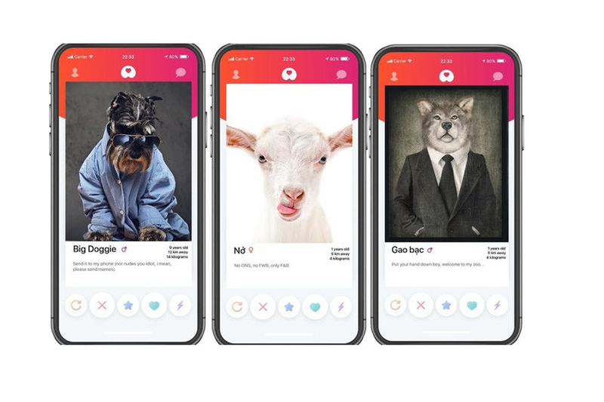

Get bone (app)

Advantages and Disadvantages of Get bone

|  |  |
| --- | --- |
| **Advantages** | **Disadvantages** |
| * Provide news and more information about pets. * Interface is easy to use and be like Tinder * Support finding mates. | * Only news, no communication between users |

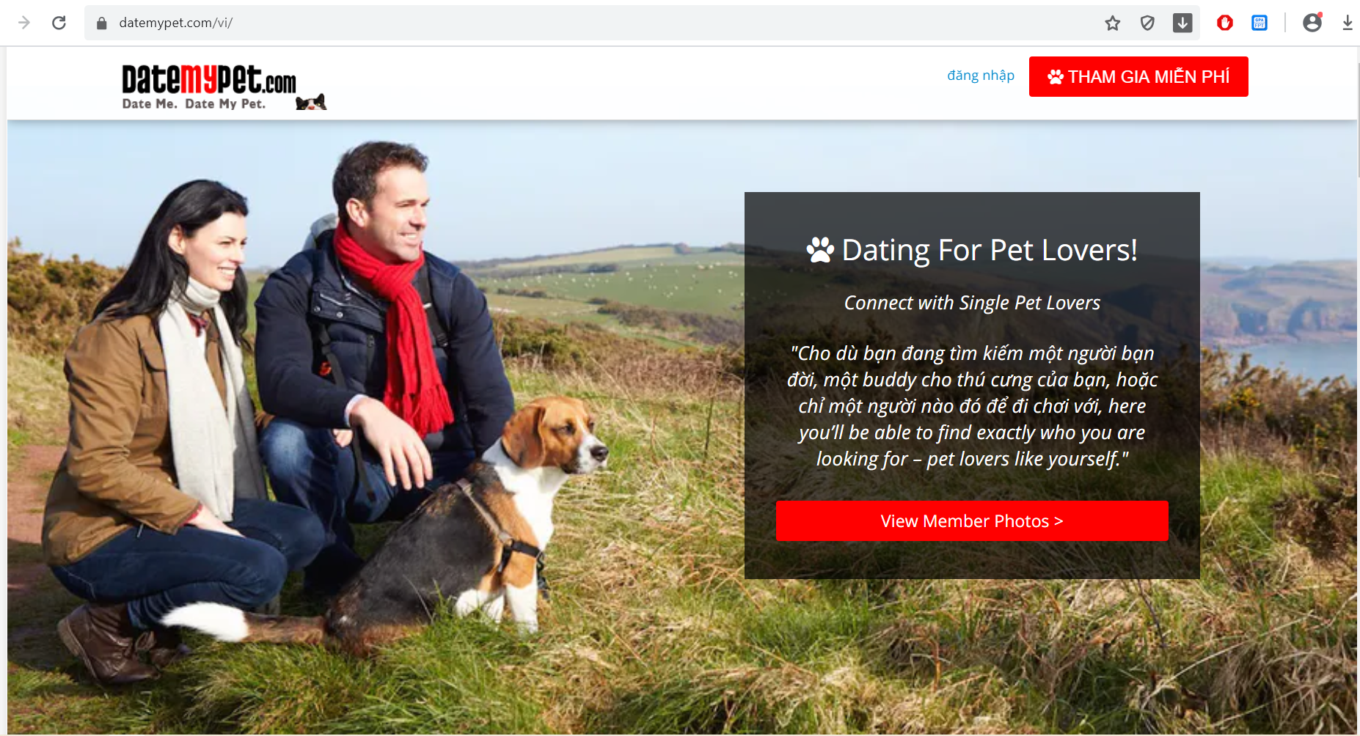

Datemypet.com

|  |  |
| --- | --- |
| **Advantages** | **Disadvantages** |
| * Provide news and more information about pets. | * Not support finding mates. * Only news, no communication between users |

## The Proposal

### The idea

We want to build a mobile application where everyone can find the half of their pets, or simply want to know about other pets. Major of application is finding the mates for their pets based on automation mode or manual mode. In the app, people maybe complete the user’s profile; pet’s profile; upload images; match what pets they want. In addition, everyone can connect and chat about pets. It helps making pets dating becomes easy, safe and enhance the community. Our idea has two part: mobile application for user and website for manager.

### The proposal

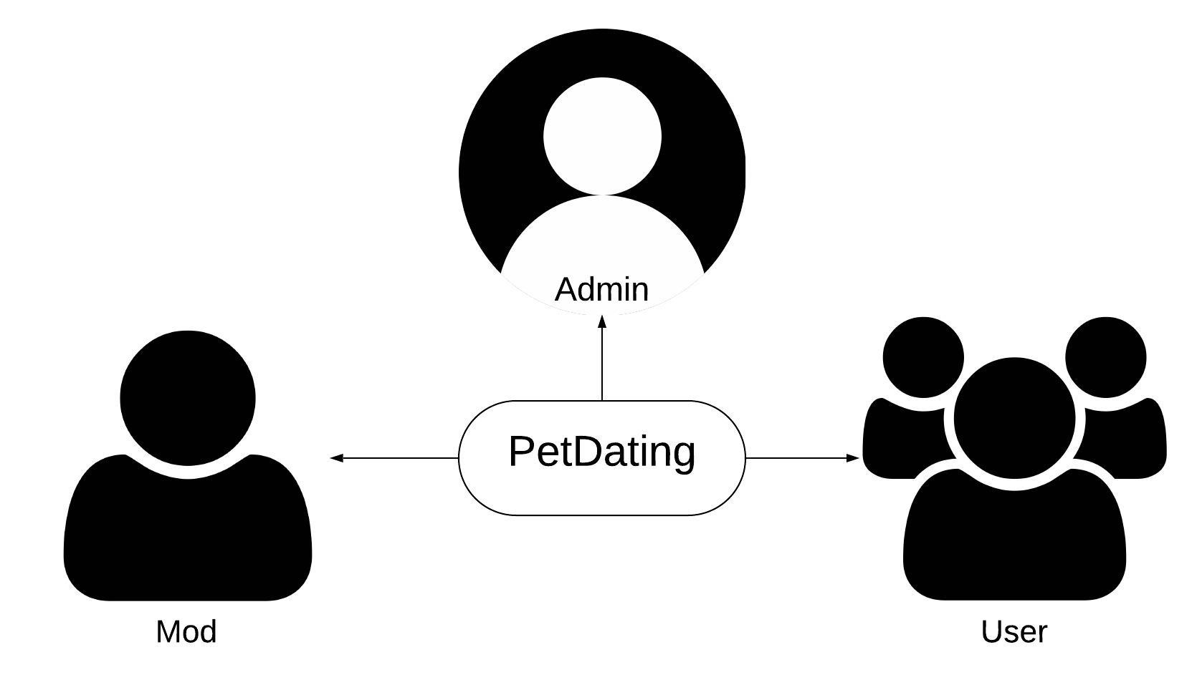

Figure - Roles in PD system

### System functions

There are three roles and responsibilities of each role on PetDating:

|  |  |
| --- | --- |
| **Role** | **Responsibilities** |
| Admin | People who approve mod’s account to manage system. |
| Mod | Somebody who manage the PD system. But can’t approve or reject other account. |
| Users | People who join and use PD application |

The system has the following roles and main functions:

* Admin:

+ Login and Logout to website.

+ Authorize to moderator.

* Mod:

+ Login and Logout to website.

+ Review reports from user.

+ Ban and Unban user.

* Users

+ Login and Logout to mobile application.

+ View user profile and modify your profile.

+ Create, modify your pet profile and view the pet profile. The pet profile defines the name, sex, age, … of pets.

+ Upload images and set privacy such as private or public.

+ Users can use dating function to find mates for pets. There are two types of finding mates:

* + Find mates by automation: Application suggests pets base on your nearly location and all of pets in your profile.
  + Find mates by manual: Application suggests pets base on your choosing.

+ Users can use chatting system to connect to other users.

+ Feedback about system.

+ Report other account.

### Business flow

* **Authorization process**

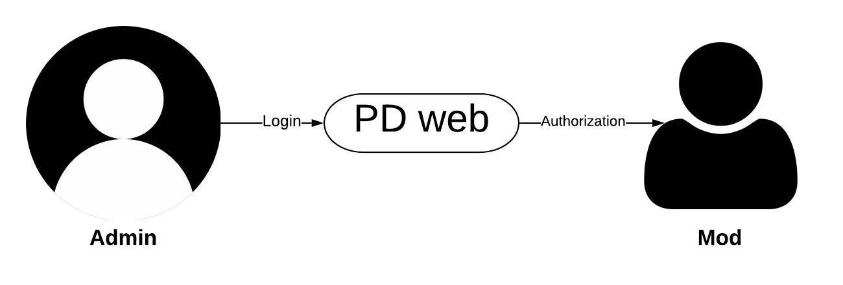

Figure - Process of authorization on PD

* **Review report process**

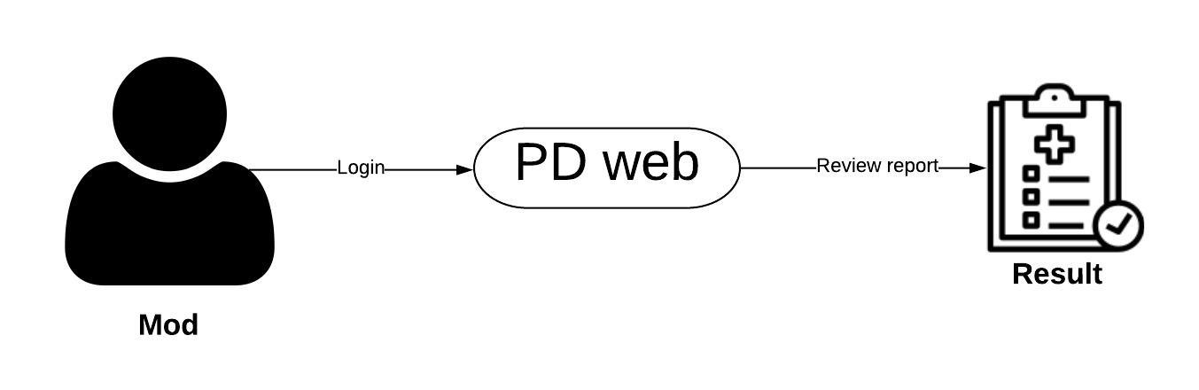

Figure 5 - Process of review report on PD

* **Ban and unban user**

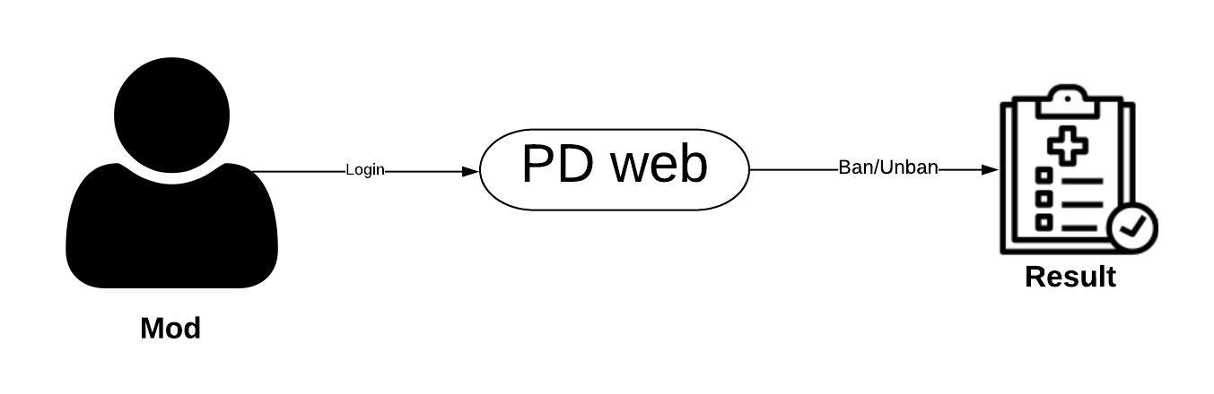

Figure 6 - Process of ban/unban on PD

* **Dating process**
* **User management process**

**CHAPTER 3: SOFTWARE REQUIREMENT SPECIFICATION**

* 1. Purpose

This chapter outlines functional and non-functional requirements of our system. It also provides some format constraints in common requirements and project success criteria. The content of this chapter is used as the basis for the work in the subsequent chapters.

* 1. Functional Requirement

3. 2. 1. Use case diagram

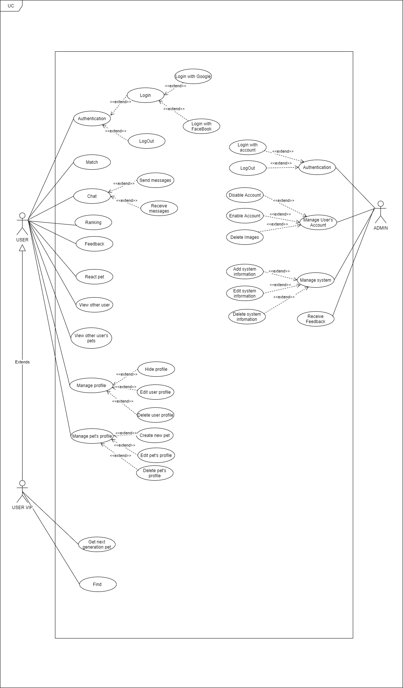

Figure - Use case diagram

* + 1. Business rules

|  |  |
| --- | --- |
| **ID** | **Description** |
| 1 | Google+ account or Facebook account must be valided. |
| 2 | Admin’s password must not be stored as plain text. Instead it must be hashed using a secure hash algorithm. |
| 3 | The field must be filled by characters consist of alphabet and numbers. |
| 4 | The field must be filled by characters consist of alphabet. |
| 5 | The field must be not empty. |
| 6 | The characters of field is greater than 10. |
| 7 | The characters of field is greater than 5. |
| 8 | The maximum characters of field is 30. |
| 9 | The maximum characters of field is 20. |
| 10 | The characters of field is only number |
| 11 | Image file type must be image type. |

Table - Business rules

* + 1. Use case list

|  |  |
| --- | --- |
| **Actors** | **Description** |
| User | Everyone who has an account on the PetDating system and used it. |
| Admin | People who has responsibilities about system |

|  |  |  |
| --- | --- | --- |
| **ID** | **Actor** | **Name** |
| AD-UC-1.0 | Admin | Login with account |
| AD-UC-2.0 | Logout |
| AD-UC-3.0 | Disable Account |
| AD-UC-4.0 | Enable Account |
| AD-UC-5.0 | Delete Images |
| AD-UC-6.0 | Manage system |
| AD-UC-7.0 | Receive Feedback |
| US-UC-1.0 | User | Login with Goole/Facebook/(Phone number) |
| US-UC-2.0 | Logout |
| US-UC-3.0 | Match |
| US-UC-4.0 | Send messages |
| US-UC-5.0 | Receive message |
| US-UC-6.0 | Ranking |
| US-UC-7.0 | Feedback |
| US-UC-8.0 | React pet |
| US-UC-9.0 | View other user |
| US-UC-10.0 | View other user’s pets |
| US-UC-11.0 | Hide profile |
| US-UC-12.0 | Edit user’s profile |
| US-UC-13.0 | Delete user’s profile |
| US-UC-14.0 | Create new pet |
| US-UC-15.0 | Edit pet’s profile |
| US-UC-16.0 | Delete pet’s profile |
| US-UC-17.0 | Find |
| US-UC-18.0 | Get next generation pet |

* + 1. Use case specification
       1. Admin

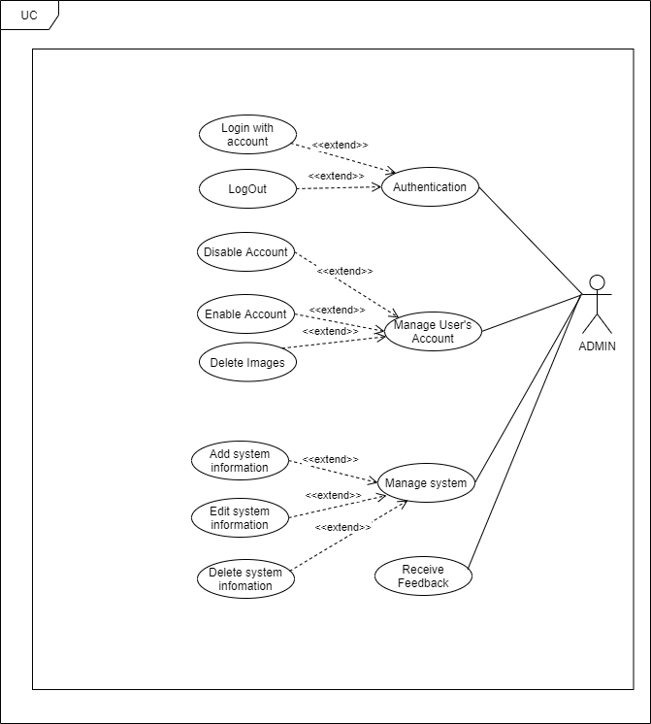

* + - * 1. Authentication

* **Login with account**

|  |  |  |  |
| --- | --- | --- | --- |
| **USECASE AD-UC-1.0** **SPECIFICATION** | | | |
| **Use case ID** | AD-UC-1.0 | **Use case version** | V1.0 |
| **Use case name** | Login with account | | |
| **Author** | Nguyen Do Anh Khuong | | |
| **Date** | 09/07/2020 | **Priority** | High |
| **Primary actor** | Admin | **Secondary actor** | N/A |
| **Description** | Allows admin login to PD system in website. | | |
| **Pre-condition** | Admin has an account and the account is still working. | | |
| **Post-condition** | When the normal flow completes successfully, the login status is set to true, and the access token is saved on the website. | | |
| **Trigger** |  | | |
| **Main flow:**   |  |  |  | | --- | --- | --- | | **No.** | **Actor events** | **System respond** | | **1.** | Admin goes to login page |  | | **2.** |  | Website displays the login form | | **3.** | Admin fills account and password then clicks “Login” button. |  | | **4.** |  | System generates cookies and save them. | | **5.** |  | Website navigates to homepage. |   **Alternative Flows: Admin logged and not yet log out.**   |  |  |  | | --- | --- | --- | | **No.** | **Actor events** | **System respond** | | **1.** | Admin goes to homepage |  | | **2.** |  | Website checks cookies then navigates to login page if not exist cookies. |   **Extension Flows: N/A**  **Exception:**  **AD1.0-E1 – Cannot connect with Account API**  System displays error message.  **AD1.0-E2 – Wrong account or password**  System displays error message and requests login again.    **Business Rules: B3, B4** | | | |
|  | | | |

\***Logout**

|  |  |  |  |
| --- | --- | --- | --- |
| **USECASE AD-UC-2.0** **SPECIFICATION** | | | |
| **Use case ID** | AD-UC-2.0 | **Use case version** | V1.0 |
| **Use case name** | LogOut | | |
| **Author** | Nguyen Do Anh Khuong | | |
| **Date** | 09/07/2020 | **Priority** | High |
| **Primary actor** | Admin | **Secondary actor** | N/A |
| **Description** | Log out the PD System. | | |
| **Pre-condition** | Has logged into PD system. | | |
| **Post-condition** | When the normal flow completes successfully, the login status is set to false, and the access token is cleared. | | |
| **Trigger** |  | | |
| **Main flow:**   |  |  |  | | --- | --- | --- | | **No.** | **Actor events** | **System respond** | | **1.** | Clicks icon “Account” on top right of website. |  | | **2.** |  | Website displays “Account Management” pop-up | | **3.** | Admin/Mod clicks “Logout” on top right of website. |  | | **4.** |  | Website navigates to Login page. |   **Alternative Flows: N/A**  **Extension Flows:**  **Exception: N/A**  **Business Rules: N/A** | | | |
|  | | | |

**\*Disable Account**

|  |  |  |  |
| --- | --- | --- | --- |
| **USECASE AD-UC-3.0** **SPECIFICATION** | | | |
| **Use case ID** | AD-UC-3.0 | **Use case version** | V1.0 |
| **Use case name** | Disable Account | | |
| **Author** | Nguyen Do Anh Khuong | | |
| **Date** | 16/07/2020 | **Priority** | High |
| **Primary actor** | Admin | **Secondary actor** | N/A |
| **Description** | Allows admin to disable account of user (ban) | | |
| **Pre-condition** | Admin logged in to system. | | |
| **Post-condition** | User’s Account was banned | | |
| **Trigger** |  | | |
| **Main flow:**   |  |  |  | | --- | --- | --- | | **No.** | **Actor events** | **System respond** | | **1.** | Clicks icon “Manage Profile” on top of website. |  | | **2.** |  | Website displays “Manage Profile ” screen | | **3.** | Choose account wanna ban and click on disable button |  | | **4.** |  | Website show confirm dialog on screen | | **5.** | Fills all require field and presses the “Confirm” button |  | | **6.** |  | Shows sucess message |   **Alternative Flows: N/A**  **Extension Flows: N/A**  **Exception: N/A**  **Business Rules: N/A** | | | |
|  | | | |

**\* Enable Account**

|  |  |  |  |
| --- | --- | --- | --- |
| **USECASE AD-UC-4.0** **SPECIFICATION** | | | |
| **Use case ID** | AD-UC-4.0 | **Use case version** | V1.0 |
| **Use case name** | Enable Account | | |
| **Author** | Nguyen Do Anh Khuong | | |
| **Date** | 16/07/2020 | **Priority** | Medium |
| **Primary actor** | Admin | **Secondary actor** | N/A |
| **Description** | Administrator Enable user’s Account. | | |
| **Pre-condition** | Admin has logged into system by admin account.  Account have been banned | | |
| **Post-condition** | User’s Account was Enable ( unbanned) | | |
| **Trigger** |  | | |
| **Main flow:**   |  |  |  | | --- | --- | --- | | **No.** | **Actor events** | **System respond** | | **1.** | Admin clicks “Manage Profile” on left-menu |  | | **2.** |  | Website navigates to “Manage Profile” page | | **3.** | Choose account wanna Enable and click on “disable/enable” button |  | | **4.** |  | Website show “confirm” dialog on screen | | **5.** | Fills all require field and presses the “Confirm” button |  | | **6.** |  | Shows sucess message |   **Alternative Flows: N/A**  **Extension Flows: N/A**  **Exception:**  **AD6.0-E1 – Cannot communicate with API server**  System displays error message.  **Business Rules: N/A** | | | |
|  | | | |

**\* Delete Image**

|  |  |  |  |
| --- | --- | --- | --- |
| **USECASE AD-UC-5.0** **SPECIFICATION** | | | |
| **Use case ID** | AD-UC-5.0 | **Use case version** | V1.0 |
| **Use case name** | Delete Image | | |
| **Author** | Nguyen Do Anh Khuong | | |
| **Date** | 16/07/2020 | **Priority** | High |
| **Primary actor** | Admin | **Secondary actor** | N/A |
| **Description** | Administrator can View and detele image of User’s Account. | | |
| **Pre-condition** | Admin has logged into system by admin account. | | |
| **Post-condition** | Image have been deleted | | |
| **Trigger** |  | | |
| **Main flow:**   |  |  |  | | --- | --- | --- | | **No.** | **Actor events** | **System respond** | | **1.** | Admin clicks “Account Manager” on left-menu |  | | **2.** |  | Website navigates to “Account manager” page | | **3.** | Admin can view , and search account was feedbacked |  | | **4.** |  | Website show information of user | | **5.** | Admin change information and  Admin clicks “detele” beside image |  | | **6.** |  | Website reloaded and show new information |   **Alternative Flows: N/A**  **Extension Flows: N/A**  **Exception:**  **AD6.0-E1 – Cannot communicate with API server**  System displays error message.  **Business Rules: N/A** | | | |
|  | | | |

**\*Manage system**

|  |  |  |  |
| --- | --- | --- | --- |
| **USECASE AD-UC-6.0** **SPECIFICATION** | | | |
| **Use case ID** | AD-UC-6.0 | **Use case version** | V1.0 |
| **Use case name** | Manager system | | |
| **Author** | Nguyen Do Anh Khuong | | |
| **Date** | 16/07/2020 | **Priority** | High |
| **Primary actor** | Admin | **Secondary actor** | N/A |
| **Description** | Administrator can manage information of system | | |
| **Pre-condition** | Admin has logged into system by admin account. | | |
| **Post-condition** |  | | |
| **Trigger** |  | | |
| **Main flow:**   |  |  |  | | --- | --- | --- | | **No.** | **Actor events** | **System respond** | | **1.** | Admin clicks “Manager” on left-menu |  | | **2.** |  | Website navigates to “Manager” page | | **3.** | Admin choose “system manager” |  | | **4.** |  | Website shows “System Manager” screen | | **5.** | Admin can view , change information (add , edit ,delete ) |  | | **6.** |  | Website reloaded and show new information |   **Alternative Flows: N/A**  **Extension Flows: N/A**  **Exception:**  **AD6.0-E1 – Cannot communicate with API server**  System displays error message.  **Business Rules: N/A** | | | |
|  | | | |

**\*Receive Feedback**

|  |  |  |  |
| --- | --- | --- | --- |
| **USECASE AD-UC-7.0** **SPECIFICATION** | | | |
| **Use case ID** | AD-UC-7.0 | **Use case version** | V1.0 |
| **Use case name** | Manager system | | |
| **Author** | Nguyen Do Anh Khuong | | |
| **Date** | 16/07/2020 | **Priority** | High |
| **Primary actor** | Admin | **Secondary actor** | N/A |
| **Description** | Administrator see all of feed back from user | | |
| **Pre-condition** | Admin has logged into system by admin account. | | |
| **Post-condition** |  | | |
| **Trigger** |  | | |
| **Main flow:**   |  |  |  | | --- | --- | --- | | **No.** | **Actor events** | **System respond** | | **1.** | Admin clicks “Feedback” on left-menu |  | | **2.** |  | Website navigates to “FeedBack” page | | **3.** |  | Website show list all of feedback |   **Alternative Flows: N/A**  **Extension Flows: N/A**  **Exception:**  **AD6.0-E1 – Cannot communicate with API server**  System displays error message.  **Business Rules: N/A** | | | |
|  | | | |

* + - 1. User

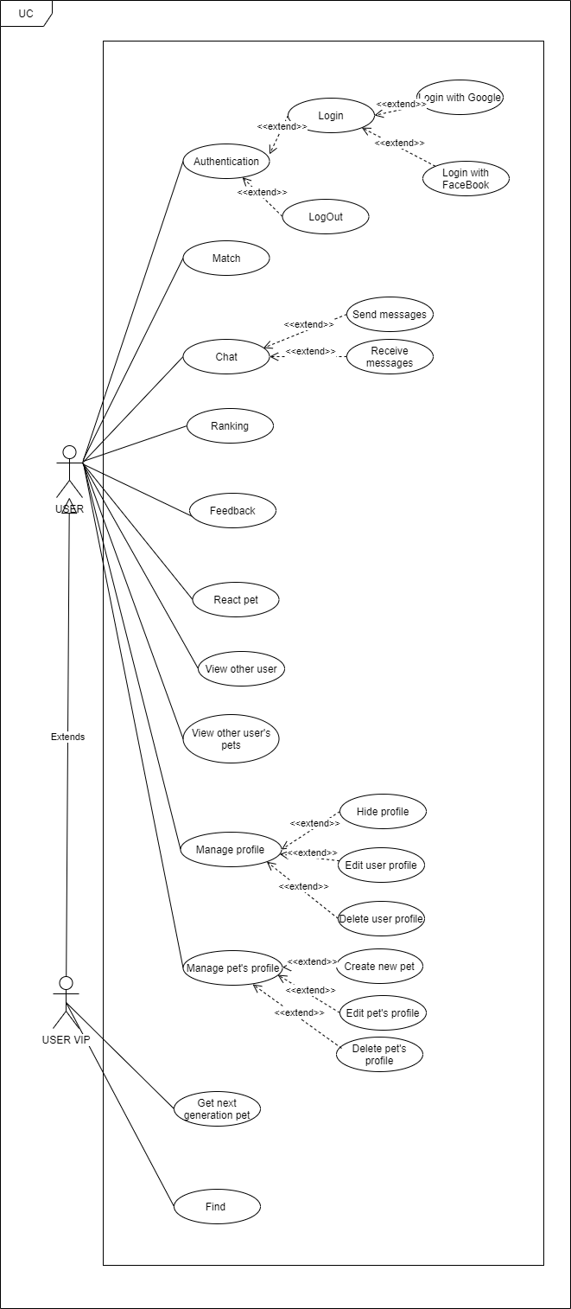

* + - * 1. Authentication

**\*Login with Google or Facebook**

|  |  |  |  |
| --- | --- | --- | --- |
| **USECASE US-UC-1.0** **SPECIFICATION** | | | |
| **Use case ID** | US-UC-1.0 | **Use case version** | V1.0 |
| **Use case name** | Login with Google+ or Facebook | | |
| **Author** | Nguyen Đỗ Anh Khuong | | |
| **Date** | 09/07/2020 | **Priority** | High |
| **Primary actor** | User | **Secondary actor** | N/A |
| **Description** | Allows User login to PD system in mobile application. | | |
| **Pre-condition** | People has a Google/Facebook account and the account is still working. | | |
| **Post-condition** | When the normal flow completes successfully, the login status is set to true, and the access token is saved on the application. | | |
| **Trigger** |  | | |
| **Main flow:**   |  |  |  | | --- | --- | --- | | **No.** | **Actor events** | **System respond** | | **1.** | User opens PD application |  | | **2.** |  | App displays title “Đăng nhập vào PET-DATING”, “Đăng nhập với Google+” button and “Đăng nhập với Facebook” button. | | **3.** | User clicks “Đăng nhập với Google+” or “Đăng nhập với Facebook”. |  | | **4.** |  | App shows a pop-up login. | | **5.** | User fills email and password or choose account (if signed in before) |  | | **6.** |  | System generates access token, user profile and save it on application. | | **7.** |  | App navigates to inside app. |   **Alternative Flows: User logged and not yet log out.**   |  |  |  | | --- | --- | --- | | **No.** | **Actor events** | **System respond** | | **1.** | User opens PD application |  | | **2.** |  | Application checks data then navigates to inside app. |   **Extension Flows: N/A**  **Exception:**  **US1.0-E1 – Cannot connect with Google API**  System displays error message.  **US1.0-E2 – Cannot connect with Facebook API**  System displays error message.    **Business Rules: B1** | | | |
|  | | | |

\***Logout**

|  |  |  |  |
| --- | --- | --- | --- |
| **USECASE US-UC-2.0** **SPECIFICATION** | | | |
| **Use case ID** | US-UC-2.0 | **Use case version** | V1.0 |
| **Use case name** | LogOut | | |
| **Author** | Nguyen Do Anh Khuong | | |
| **Date** | 09/07/2020 | **Priority** | High |
| **Primary actor** | User | **Secondary actor** | N/A |
| **Description** | Log out the app | | |
| **Pre-condition** | Has logged into on application | | |
| **Post-condition** | When the normal flow completes successfully, the login status is set to false, and the access token is cleared. | | |
| **Trigger** |  | | |
| **Main flow:**   |  |  |  | | --- | --- | --- | | **No.** | **Actor events** | **System respond** | | **1.** | Clicks icon “Account” on top right of app |  | | **2.** |  | Application displays “Account “ screen | | **3.** | User clicks “Logout” on tab |  | | **4.** |  | Website navigates to Login screen |   **Alternative Flows: N/A**  **Extension Flows:**  **Exception: N/A**  **Business Rules: N/A** | | | |
|  | | | |

* + - * 1. Match

**\*Matching**

|  |  |  |  |
| --- | --- | --- | --- |
| **USECASE US-UC-3.0** **SPECIFICATION** | | | |
| **Use case ID** | US-UC-3.0 | **Use case version** | V1.0 |
| **Use case name** | Match | | |
| **Author** | Nguyen Do Anh Khuong | | |
| **Date** | 09/07/2020 | **Priority** | High |
| **Primary actor** | User | **Secondary actor** | N/A |
| **Description** | User selects pet for dating. | | |
| **Pre-condition** | User has logged into application. | | |
| **Post-condition** |  | | |
| **Trigger** |  | | |
| **Main flow:**   |  |  |  | | --- | --- | --- | | **No.** | **Actor events** | **System respond** | | **1.** | User choose Matching screen. |  | | **2.** |  | Application displays matching Screen | | **3.** | User choose pet active on list pets |  | | **4.** |  | Screen display pet was choosed | | **5** | User choose “X” button. Or drag pet card left to skip |  | | **6.** | User choose “V” button. Or drag pet card right to match |  | | **7.** |  | Application next to other pet  display list of pets | | **8.** | User Vip can use “Rollback “ to back pet was passed |  | | **9.** |  | If user match with other pet , screen display message “Matched !“ |   **Alternative Flows: N/A**  **Extension Flows: N/A**  **Exception:**  **US10.0-E1 – Cannot communicate with API server**  System displays error message.  **Business Rules: N/A** | | | |
|  | | | |

* + - * 1. Chat

1. **\*Send message**

|  |  |  |  |
| --- | --- | --- | --- |
| **USECASE US-UC-4.0** **SPECIFICATION** | | | |
| **Use case ID** | US-UC-4.0 | **Use case version** | V1.0 |
| **Use case name** | Send message | | |
| **Author** | Nguyen Do Anh Khuong | | |
| **Date** | 09/07/2020 | **Priority** | High |
| **Primary actor** | User | **Secondary actor** | N/A |
| **Description** | User sends messages to others user. | | |
| **Pre-condition** | User has logged into application. | | |
| **Post-condition** |  | | |
| **Trigger** |  | | |
| **Main flow:**   |  |  |  | | --- | --- | --- | | **No.** | **Actor events** | **System respond** | | **1.** | Do US-UC-2.0 then view receiver profile. |  | | **2.** |  | Application displays receiver profile. | | **3.** | User clicks “Chat” button in receiver profile. |  | | **4.** |  | Application displays “Chat” screen. | | **5.** | User enters message then clicks icon send. |  | |  |  | Application sends message to receiver. |   **Alternative Flows:**   |  |  |  | | --- | --- | --- | | **No.** | **Actor events** | **System respond** | | **1.** | User click message icon on top tab bar |  | | **2.** |  | Application displays “ConversationList” screen. | | **3.** | User clicks specific conversation |  | | **4.** |  | Application displays “Chat” screen. | | **5.** | User fills receiver name and enter message then clicks icon send. |  | |  |  | Application sends message to receiver. |   **Extension Flows: N/A**  **Exception:**  **US5.0-E1 – Cannot communicate with API server**  System displays error message.  **US5.0-E2 – User does not exist or empty**  System cannot send message.  **Business Rules:N/A** | | | |
|  | | | |

1. **\*Receive message**

|  |  |  |  |
| --- | --- | --- | --- |
| **USECASE US-UC-5.0** **SPECIFICATION** | | | |
| **Use case ID** | US-UC-5.0 | **Use case version** | V1.0 |
| **Use case name** | Receive message | | |
| **Author** | Nguyen Do Anh Khuong | | |
| **Date** | 09/07/2020 | **Priority** | High |
| **Primary actor** | User | **Secondary actor** | N/A |
| **Description** | User receives messages from others user. | | |
| **Pre-condition** | User has logged into application. | | |
| **Post-condition** |  | | |
| **Trigger** |  | | |
| **Main flow:**   |  |  |  | | --- | --- | --- | | **No.** | **Actor events** | **System respond** | | **1.** |  | Application display notification | | **2.** | User click message icon on top tab bar |  | | **3.** |  | Application displays “ConversationList” screen. | | **4.** | User clicks sender name to read message. |  | | **5.** |  | Application displays chatting screen with sender. |   **Alternative Flows: N/A**  **Extension Flows: N/A**  **Exception:**  **US6.0-E1 – Cannot communicate with API server**  System displays error message.    **Business Rules: N/A** | | | |
|  | | | |

**\*Ranking**

|  |  |  |  |
| --- | --- | --- | --- |
| **USECASE US-UC6.0** **SPECIFICATION** | | | |
| **Use case ID** | US-UC-6.0 | **Use case version** | V1.0 |
| **Use case name** | Ranking | | |
| **Author** | Nguyen Do Anh Khuong | | |
| **Date** | 09/07/2020 | **Priority** | High |
| **Primary actor** | User | **Secondary actor** | N/A |
| **Description** | User see top of 10 pet have most reaction | | |
| **Pre-condition** | User has logged into application. | | |
| **Post-condition** |  | | |
| **Trigger** |  | | |
| **Main flow:**   |  |  |  | | --- | --- | --- | | **No.** | **Actor events** | **System respond** | | **1.** | User choose sidebar |  | | **2.** |  | Application display sidebar with menu ( feedback , ranking, privacy ,..) | | **3.** | User choose ranking |  | | **4.** |  | Application display top of pet, that have most of like |   **Alternative Flows: N/A**  **Extension Flows: N/A**  **Exception:**  **US6.0-E1 – Cannot communicate with API server**  System displays error message.    **Business Rules: N/A** | | | |
|  | | | |

* + - * 1. Feedback

**\*Feedback**

|  |  |  |  |
| --- | --- | --- | --- |
| **USECASE US-UC-7.0** **SPECIFICATION** | | | |
| **Use case ID** | US-UC-7.0 | **Use case version** | V1.0 |
| **Use case name** | Feedback | | |
| **Author** | Nguyen Do Anh Khuong | | |
| **Date** | 09/07/2020 | **Priority** | Medium |
| **Primary actor** | User | **Secondary actor** | N/A |
| **Description** | User can feed back about bug, issue … to admin | | |
| **Pre-condition** | User has logged into application. | | |
| **Post-condition** |  | | |
| **Trigger** |  | | |
| **Main flow:**   |  |  |  | | --- | --- | --- | | **No.** | **Actor events** | **System respond** | | **1.** | User choose sidebar |  | | **2.** |  | Application display sidebar with menu ( feedback , ranking, privacy ,..) | | **3.** | User choose “Feedback” |  | | **4.** |  | Application display Text area to feedback | | **5.** | User Enter his feedback on text area  And choose “submit” |  | | **6.** |  | Show message “ your feedback was send to admin, thank you for your feedback !” |   **Alternative Flows: N/A**  **Extension Flows: N/A**  **Exception:**  **US4.0-E1 – Cannot communicate with API server**  System displays error message.  **US4.0-E2 – User does not exist and not match**  System displays nothing.  **Business Rules: N/A** | | | |

* + - * 1. React pet

**\*React pet**

|  |  |  |  |
| --- | --- | --- | --- |
| **USECASE US-UC-8.0** **SPECIFICATION** | | | |
| **Use case ID** | US-UC-8.0 | **Use case version** | V1.0 |
| **Use case name** | React pet | | |
| **Author** | Nguyen Do Anh Khuong | | |
| **Date** | 10/07/2020 | **Priority** | High |
| **Primary actor** | User | **Secondary actor** | N/A |
| **Description** | User react a pet to rank pet on system | | |
| **Pre-condition** | User has logged into application. | | |
| **Post-condition** | Privacy of user is public | | |
| **Trigger** |  | | |
| **Main flow:**   |  |  |  | | --- | --- | --- | | **No.** | **Actor events** | **System respond** | | **1.** | User choose react on UC-3.0 |  | | **2.** |  | Application displays target pet’s profile. | | **3.** | User clicks react icon in target pet profile. |  | | **4.** |  | Application displays success message. |   **Alternative Flows: N/A**  **Extension Flows:**   |  |  |  | | --- | --- | --- | | **No.** | **Actor events** | **System respond** | | **1.** | Click on Pet profile |  | | **2.** |  | Application displays target profile. | | **3.** | User clicks like icon in target profile. |  | | **4.** |  | Application displays success message. |   **Exception:**  **US8.0-E1 – Cannot communicate with API server**  System displays error message.  **Business Rules: N/A** | | | |

* + - * 1. View other user

|  |  |  |  |
| --- | --- | --- | --- |
| **USECASE US-UC-9.0** **SPECIFICATION** | | | |
| **Use case ID** | US-UC-9.0 | **Use case version** | V1.0 |
| **Use case name** | View other user | | |
| **Author** | Nguyen Do Anh Khuong | | |
| **Date** | 10/07/2020 | **Priority** | Medium |
| **Primary actor** | User | **Secondary actor** | N/A |
| **Description** | User views others user’s profile. | | |
| **Pre-condition** | User has logged into application. | | |
| **Post-condition** |  | | |
| **Trigger** |  | | |
| **Main flow:**   |  |  |  | | --- | --- | --- | | **No.** | **Actor events** | **System respond** | | **1.** | User use “Match” screen and click “info” on top-right card and choose  “View owner” |  | | **2.** |  | Application displays profile screen, which includes all information of that user :  Name  Date of birth  Gender  Email  Phone  Description | | **3.** | User roll down to choose user’s profile, which user want to view |  |   **Alternative Flows: N/A**   |  |  |  | | --- | --- | --- | | **No.** | **Actor events** | **System respond** | | **1.** | User clicks top left icon on top tab bar |  | | **2.** |  | Application displays profile screen, which includes:  Name  Date of birth  Gender  Email  Phone  Description | | **3.** | User roll down to choose user’s profile, which user want to view |  |   **Extension Flows: N/A**  **Exception:**  **US7.0-E1 – Cannot communicate with API server**  System displays error message.    **Business Rules: N/A** | | | |
|  | | | |

**\*View pet’s profile**

|  |  |  |  |
| --- | --- | --- | --- |
| **USECASE US-UC-10.0** **SPECIFICATION** | | | |
| **Use case ID** | US-UC-10.0 | **Use case version** | V1.0 |
| **Use case name** | View pet’s profile | | |
| **Author** | Nguyen Do Anh Khuong | | |
| **Date** | 10/07/2020 | **Priority** | High |
| **Primary actor** | User | **Secondary actor** | N/A |
| **Description** | User views other user’s pet profile. | | |
| **Pre-condition** | User has logged into application. | | |
| **Post-condition** |  | | |
| **Trigger** |  | | |
| **Main flow:**   |  |  |  | | --- | --- | --- | | **No.** | **Actor events** | **System respond** | | **1.** | User use “Match” screen and click “info” on top-right card |  | | **2.** |  | Application displays profile screen, which includes all information of that pet :  Name  Date of birth  Gender  Weight  Breed  Description | | **3.** | User roll down to choose pet profile, which user want to view |  |   **Alternative Flows: N/A**   |  |  |  | | --- | --- | --- | | **No.** | **Actor events** | **System respond** | | **1.** | User clicks pet’s icon on “user profile “ screen |  | | **2.** |  | Application displays profile screen, which includes all information of that pet :  Name  Date of birth  Gender  Weight  Breed | | **3.** | User roll down to choose pet profile, which user want to view |  |   **Extension Flows: N/A**  **Exception:**  **US7.0-E1 – Cannot communicate with API server**  System displays error message.    **Business Rules: N/A** | | | |
|  | | | |

* + - * 1. Hide profile

**\*Hide profile**

|  |  |  |  |
| --- | --- | --- | --- |
| **USECASE US-UC-11.0** **SPECIFICATION** | | | |
| **Use case ID** | US-UC-11.0 | **Use case version** | V1.0 |
| **Use case name** | Hide profile | | |
| **Author** | Nguyen Do Anh Khuong | | |
| **Date** | 10/07/2020 | **Priority** | Medium |
| **Primary actor** | User | **Secondary actor** | N/A |
| **Description** | User hide profile ( other user can’t see his/her profile and all of her/his pets) | | |
| **Pre-condition** | User has logged into application. | | |
| **Post-condition** |  | | |
| **Trigger** |  | | |
| **Main flow:**   |  |  |  | | --- | --- | --- | | **No.** | **Actor events** | **System respond** | | **1.** | User choose sidebar |  | | **2.** |  | Application display sidebar with menu ( feedback , ranking, privacy ,..) | | **3.** | User choose “Hide profile” |  | | **4.** |  | Show confirm message “You are sure to hide your profile “ | | **5.** | User choose “Yes” |  | |  |  | Show message “your profile was hide !” |   **Alternative Flows: N/A**  **Extension Flows: N/A**  **Exception:**  **US7.0-E1 – Cannot communicate with API server**  System displays error message.    **Business Rules: N/A** | | | |
|  | | | |

* + - * 1. Manage profile

**\*Modify user’s profile**

|  |  |  |  |
| --- | --- | --- | --- |
| **USECASE US-UC-12.0** **SPECIFICATION** | | | |
| **Use case ID** | US-UC-12.0 | **Use case version** | V1.0 |
| **Use case name** | Modify user’s profile | | |
| **Author** | Nguyen Do Anh Khuong | | |
| **Date** | 10/07/2020 | **Priority** | High |
| **Primary actor** | User | **Secondary actor** | N/A |
| **Description** | User modify own profile. | | |
| **Pre-condition** | User has logged into application. | | |
| **Post-condition** |  | | |
| **Trigger** |  | | |
| **Main flow:**   |  |  |  | | --- | --- | --- | | **No.** | **Actor events** | **System respond** | | **1.** | User clicks “Account” icon on top tab bar |  | | **2.** |  | Application displays “Account Management” screen | | **3.** |  | Application navigates to “Own Profile” screen, which include:  avata  profile  list image | | **4.** | User clicks “Modify profile”. |  | | **5.** |  | Application navigates to “Modify Profile” screen. | | **6.** | User fills and select all required information then clicks “Edit” button. |  | |  |  | Application displays success message. |   **Alternative Flows: N/A**  **Extension Flows: N/A**  **Exception:**  **US13.0-E1 – Cannot communicate with API server**  System displays error message.  **Business Rules: B5, B8, B9** | | | |
|  | | | |

* + - * 1. Delete user profile

**\*Delete user’s profile**

|  |  |  |  |
| --- | --- | --- | --- |
| **USECASE US-UC-13.0** **SPECIFICATION** | | | |
| **Use case ID** | US-UC-13.0 | **Use case version** | V1.0 |
| **Use case name** | Delete user’s profile | | |
| **Author** | Nguyen Do Anh Khuong | | |
| **Date** | 10/07/2020 | **Priority** | High |
| **Primary actor** | User | **Secondary actor** | N/A |
| **Description** | User delete his/her profile | | |
| **Pre-condition** | User has logged into application. | | |
| **Post-condition** |  | | |
| **Trigger** |  | | |
| **Main flow:**   |  |  |  | | --- | --- | --- | | **No.** | **Actor events** | **System respond** | | **1.** | User clicks “Account” icon on side tab bar |  | | **2.** |  | Application displays “Account Management” screen | | **3.** | Choose “Edit profile” |  | | **4.** |  | Application navigates to “Profile” screen, which include:  avata  profile  list image | | **5.** | User clicks “Delete profile”. |  | | **6.** |  | Show confirm message “ Do you want to delete your profile . Warn : your profile will loss all of information | | **7.** | User choose “yes”. |  | | **8.** |  | Application displays success message. |   **Alternative Flows: N/A**  **Extension Flows: N/A**  **Exception:**  **US13.0-E1 – Cannot communicate with API server**  System displays error message.  **Business Rules: N/A** | | | |

* + - * 1. Manage pet’s profile

**\*Create pet’s profile**

|  |  |  |  |
| --- | --- | --- | --- |
| **USECASE US-UC-14.0** **SPECIFICATION** | | | |
| **Use case ID** | US-UC-14.0 | **Use case version** | V1.0 |
| **Use case name** | Create pet’s profile | | |
| **Author** | Nguyen Do Anh Khuong | | |
| **Date** | 10/07/2020 | **Priority** | High |
| **Primary actor** | User | **Secondary actor** | N/A |
| **Description** | User adds own pet’s profile. | | |
| **Pre-condition** | User has logged into application. | | |
| **Post-condition** |  | | |
| **Trigger** |  | | |
| **Main flow:**   |  |  |  | | --- | --- | --- | | **No.** | **Actor events** | **System respond** | | **1.** | User clicks pet icon on top tab bar |  | | **2.** |  | Application displays “Pet Management” screen | | **3.** | User click new icon. |  | | **4.** |  | Application navigates to “Create Pet” screen. | | **5.** | User fills and select all required information then clicks “Add” button. |  | | **6.** |  | Application displays success message. |   **Alternative Flows: N/A**  **Extension Flows: N/A**  **Exception:**  **US15.0-E1 – Cannot communicate with API server**  System displays error message.  **Business Rules: B5, B10** | | | |

**\*Edit pet’s profile**

|  |  |  |  |
| --- | --- | --- | --- |
| **USECASE US-UC-15.0** **SPECIFICATION** | | | |
| **Use case ID** | US-UC-15.0 | **Use case version** | V1.0 |
| **Use case name** | Edit pet’s profile | | |
| **Author** | Nguyen Do Anh Khuong | | |
| **Date** | 10/07/2020 | **Priority** | High |
| **Primary actor** | User | **Secondary actor** | N/A |
| **Description** | User edit own pet’s profile. | | |
| **Pre-condition** | User has logged into application. | | |
| **Post-condition** |  | | |
| **Trigger** |  | | |
| **Main flow:**   |  |  |  | | --- | --- | --- | | **No.** | **Actor events** | **System respond** | | **1.** | Do US-UC-16.0 then click “Edit profile” |  | | **2.** |  | Application navigates to “Edit Pet Profile” screen | | **3.** | User fills and select all required information then clicks “Edit” button. |  | |  |  | Application displays success message. |   **Alternative Flows: N/A**  **Extension Flows: N/A**  **Exception:**  **US17.0-E1 – Cannot communicate with API server**  System displays error message.  **Business Rules: B7, B8,B9** | | | |
|  | | | |

\***Delete pet’s profile**

|  |  |  |  |
| --- | --- | --- | --- |
| **USECASE US-UC-16.0** **SPECIFICATION** | | | |
| **Use case ID** | US-UC-16.0 | **Use case version** | V1.0 |
| **Use case name** | Delete pet’s profile | | |
| **Author** | Nguyen Do Anh Khuong | | |
| **Date** | 10/07/2020 | **Priority** | High |
| **Primary actor** | User | **Secondary actor** | N/A |
| **Description** | User delete own pet’s profile. | | |
| **Pre-condition** | User has logged into application. | | |
| **Post-condition** |  | | |
| **Trigger** |  | | |
| **Main flow:**   |  |  |  | | --- | --- | --- | | **No.** | **Actor events** | **System respond** | | **1.** | User open “ pet profile “ screen |  | | **2.** |  | Show “ Pet profile “ screen | | **3.** | Scroll down and choose “Delete Pet” |  | | **4.** |  | Application navigates to “delete Pet Profile” popup confirm | | **5.** | User see information then clicks “yes” button. |  | | **6.** |  | Application displays success message. |   **Alternative Flows: N/A**  **Extension Flows: N/A**  **Exception:**  **US17.0-E1 – Cannot communicate with API server**  System displays error message.  **Business Rules: N/A** | | | |
|  | | | |

\***Find**

|  |  |  |  |
| --- | --- | --- | --- |
| **USECASE US-UC-17.0** **SPECIFICATION** | | | |
| **Use case ID** | US-UC-17.0 | **Use case version** | V1.0 |
| **Use case name** | Find | | |
| **Author** | Nguyen Do Anh Khuong | | |
| **Date** | 10/07/2020 | **Priority** | High |
| **Primary actor** | User | **Secondary actor** | N/A |
| **Description** | User Find other user/pets around | | |
| **Pre-condition** | User has logged into application. | | |
| **Post-condition** |  | | |
| **Trigger** |  | | |
| **Main flow:**   |  |  |  | | --- | --- | --- | | **No.** | **Actor events** | **System respond** | | **1.** | Choose “Find” icon on sidebar |  | | **2.** |  | Application navigates to “Find” screen | | **3.** | User setting distance and gender of pet/user . |  | | **4.** |  | Show list pet/user appropriate with condition | | **5.** | Choose pet/user you want to see more information |  | | **6.** |  | Show detail information of that pet/user |   **Alternative Flows: N/A**  **Extension Flows: N/A**  **Exception:**  **US17.0-E1 – Cannot communicate with API server**  System displays error message.  **Business Rules: N/A** | | | |
|  | | | |

* + - * 1. Get next generation

\***Get next generation**

|  |  |  |  |
| --- | --- | --- | --- |
| **USECASE US-UC-18.0** **SPECIFICATION** | | | |
| **Use case ID** | US-UC-18.0 | **Use case version** | V1.0 |
| **Use case name** | Get next generation | | |
| **Author** | Nguyen Do Anh Khuong | | |
| **Date** | 10/07/2020 | **Priority** | High |
| **Primary actor** | User | **Secondary actor** | N/A |
| **Description** | User get predict for next generation | | |
| **Pre-condition** | User has logged into application. | | |
| **Post-condition** |  | | |
| **Trigger** |  | | |
| **Main flow:**   |  |  |  | | --- | --- | --- | | **No.** | **Actor events** | **System respond** | | **1.** | Open “Match “ screen and click icon “next generation” on slide card |  | | **2.** |  | Application navigates to “view next generation” screen | | **3.** | User see information then clicks “confirm” button. |  |   **Alternative Flows: N/A**  **Extension Flows: N/A**  **Exception:**  **US17.0-E1 – Cannot communicate with API server**  System displays error message.  **Business Rules: N/A** | | | |
|  | | | |

# **CHAPTER 4: SOFTWARE DESIGN**

## Purpose

This chapter is to give the developer team an overview of what the system’s architecture  
is, and how they should be implemented. This chapter consists of:

* Overview of system architecture
* Database Design
* Detailed Design

## A

## A

## Database Design

### 4.1.1 Entity relationship diagram

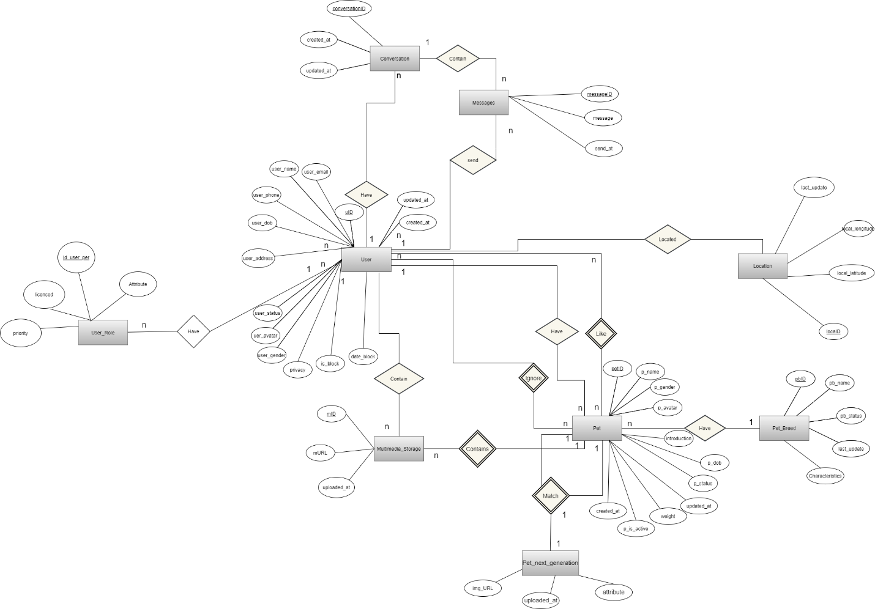

Figure - Entity relationship diagram

|  |  |  |
| --- | --- | --- |
| **Entity** | **Attributes** | **Description** |
| User | **uID** | id of user |
| user_email | email of user |
| user_name | name of user |
| user_avatar | avatar of user |
| user_gender | gender of user |
| user_phone | phone of user |
| user_dob | birthdate of user |
| user_address | address of user |
| user_status | status of user |
| privacy | privacy of user |
| is_block | user is blocked or not |
| date_block | date expire blocked |
| local | Real-time location |
| created_at | datetime that the user was created |
| updated_at | datetime that the user was updated |
| Pet | **petID** | id of pet |
| p_name | name of pet |
| p_dob | birthdate of pet |
| p_gender | gender of pet |
| p_avatar | link to the avatar of pet |
| p_status | status of pet |
| introduction | introduction of the pet |
| p_is_active | this pet is choosen |
| weight | weight of pet |
| created_at | datetime that the pet was created |
| updated_at | datetime that the pet was updated |
| Location | **loca_id** | id of pet location |
| local_latitude | latitude of location |
| loca_longitude | longitude of location |
| updated_at | datetime that the specie was updated |
| Multimedia_Storage | **mID** | id of multimedia |
| mURL | link to multimedia |
| uploaded_at | datetime that the multimedia was uploaded |
| Conversation | **conversationID** | id of conversation |
| user_one | user on conversation |
| user_two | user on conversation |
| created_at | datetime that the conversation was created |
| updated_at | datetime that the last message in conversation was updated |
| User_Role | **Id_user_per** | id of role |
| licensed | licensed of user role |
| priority | priority of user role |
| attribute | attribute of user role |
| Pet_Next_Generation | **img_URL** | url of the image |
| atribute | attribute of pet next generation |
| uploaded_at | datetime that the image was uploaded |
| Message | messageID | id of message |
| message | content of message |
| send_at | time message be send |

### Database diagram

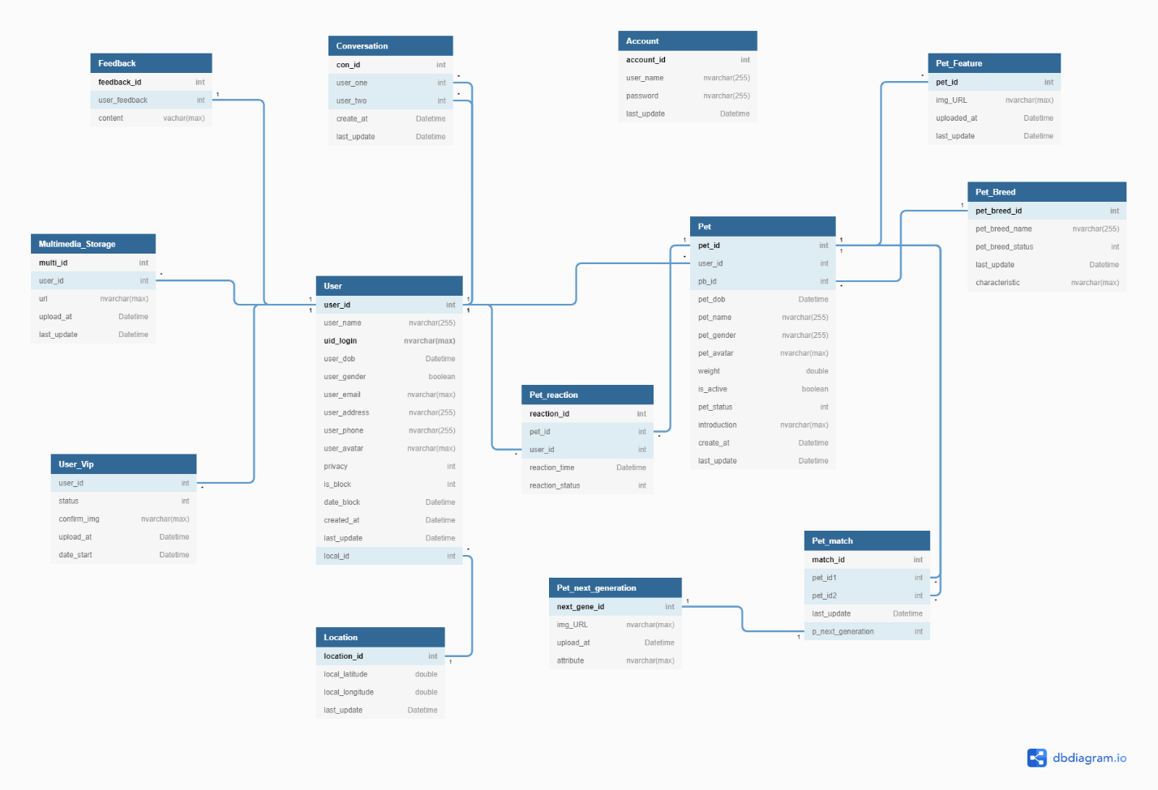

Figure - Database diagram

**Database Explanation:**

**\* User:**

|  |  |  |  |  |
| --- | --- | --- | --- | --- |
| **No** | **Field Name** | **Type** | **Allow Null** | **Desceription** |
| 1 | **uID** | int | no | id of user  **PRIMARY KEY** |
| 2 | user_email | varchar(255) | No | email of user  **UNIQUE** |
|  | uid_login | varchar(max) | No | Id login by google or facebook  **PRIMARY KEY** |
| 3 | user_name | varchar(255) | No | name of user |
| 4 | user_avatar | varchar(max) | No | avatar of user |
| 5 | user_gender | boolean | No | gender of user (true : male , false :female) |
| 6 | user_phone | varchar(20) | Yes | phone of user |
| 7 | user_dob | date | No | birthdate of user |
| 8 | user_address | varchar(max) | Yes | address of user |
| 9 | user_status | boolean | No | status of user  1: Activated - Default  0: inActivated |
| 10 | privacy | boolean | No | privacy of user  true: unhide  false : hide |
| 11 | is_block | int | No | User is blocked or not  1 : block  0 : unblock |
|  | date_block | date | No | Expire block date |
| 12 | created_at | timestamp | No | datetime that the user was created  Default: CURRENT_TIMESTAMP |
| 13 | updated_at | timestamp | No | datetime that the pet was updated  Default: CURRENT_TIMESTAMP  ON UPDATE CURRENT_TIMESTAMP |

**\* Pet:**

|  |  |  |  |  |
| --- | --- | --- | --- | --- |
| **No** | **Field Name** | **Type** | **Allow Null** | **Desceription** |
| 1 | **petID** | int | No | id of pet  **Primary key** |
| 2 | *user_id* | int | No | id of user who have pets  Foreign key references to uID in “User” table |
| 3 | *pb_id* | int | No | breed of pet  Foreign key references to pbID in “PetBreed” table |
| 5 | p_name | varchar(255) | No | name of pet |
| 6 | p_dob | date | No | birthdate of pet |
| 7 | p_gender | varchar(255) | No | gender of pet (Đực; Cái) |
| 8 | p_avatar | varchar(max) | No | avatar of pet |
| 9 | weight | double | Yes | weight of pet |
| 10 | is_active | boolean | No | pet is choosen  1: Activated  0: inActivated |
| 11 | p_status | int | No | status of pet |
| 12 | introduction | text | Yes | introduction about pet |
| 13 | created_at | timestamp | No | datetime that the pet was created  Default: CURRENT_TIMESTAMP |
| 14 | updated_id | timestamp | No | datetime that the pet was updated  Default: CURRENT_TIMESTAMP  ON UPDATE CURRENT_TIMESTAMP |

**\*Pet_Breed:**

|  |  |  |  |  |
| --- | --- | --- | --- | --- |
| **No** | **Field Name** | **Type** | **Allow Null** | **Desceription** |
| 1 | **pbID** | int | No | id of pet’s breed  **Primary key** |
| 2 | *ps_id* | int | No | id of pet’s species  Foreign key references to psID in “PetSpecies” table |
| 3 | pb_name | varchar(30) | No | name of breed |
| 4 | pb_status | boolean | No | status of breed  1: Activated - Default  0: inActivated |
| 5 | updated_at | timestamp | No | datetime that the breed was updated.  Default: CURRENT_TIMESTAMP  ON UPDATE CURRENT_TIMESTAMP |

**\* Location:**

|  |  |  |  |  |
| --- | --- | --- | --- | --- |
| **No** | **Field Name** | **Type** | **Allow Null** | **Desceription** |
| 1 | **locaID** | int | No | id of location  **Primary key** |
| 2 | local_latitude | double | No | local_latitude of location |
| 3 | local_longitude | double | No | local_longitude of location |
| 4 | updated_at | timestamp | No | time that the location was updated. |

**\* Conversation:**

|  |  |  |  |  |
| --- | --- | --- | --- | --- |
| **No** | **Field Name** | **Type** | **Allow Null** | **Desceription** |
| 1 | **conID** | int | No | id of conversation  **Primary key** |
| 2 | *userOne* | int | No | id of user one who join in a conversation  Foreign key references to uID in “User” table |
| 3 | *userTwo* | int | No | id of user two who join in a conversation  Foreign key references to uID in “User” table |
| 4 | created_at | timestamp | No | datetime that the conversation was created  Default: CURRENT_TIMESTAMP |
| 5 | updated_at | timestamp | No | datetime that the last message in conversation was updated  Default: CURRENT_TIMESTAMP  ON UPDATE CURRENT_TIMESTAMP |

**\* Mutimedia_Storage:**

|  |  |  |  |  |
| --- | --- | --- | --- | --- |
| **No** | **Field Name** | **Type** | **Allow Null** | **Desceription** |
| 1 | **mID** | int | No | id of multimedia  **Primary key** |
| 2 | *user_id* | int | No | user_id of user who has multimedia  Foreign key refernces to uID in “User” table |
| 3 | url | varchar(max) | No | url contain content |
| 4 | uploaded_at | timestamp | No | datetime that the multimedia was uploaded  Default: CURRENT_TIMESTAMP |

**\* Account**

|  |  |  |  |  |
| --- | --- | --- | --- | --- |
| **No** | **Field Name** | **Type** | **Allow Null** | **Desceription** |
| 1 | **account_id** | int | No | id of account |
| 2 | user_name | varchar(255) | No | username of account user |
| 3 | password | varchar(255) | No | password of account user |
| 4 | last_update | timestamp | No | Default: CURRENT_TIMESTAMP  ON UPDATE CURRENT_TIMESTAMP |

**\* User_Vip:**

|  |  |  |  |  |
| --- | --- | --- | --- | --- |
| **No** | **Field Name** | **Type** | **Allow Null** | **Desceription** |
| 1 | **user_id** | int | No | id of user have vip |
| 2 | status | int | No | status of user vip  1: is Vip  0: non-Vip |
| 3 | confirm_img | varchar(max) | No | image user screen shot transfer money to accounts of admin |
| 4 | upload_at | timestamp | No | Default: CURRENT_TIMESTAMP |
| 5 | date_start | Datetime | No | date admin set user is Vip |

**\* Feedback:**

|  |  |  |  |  |
| --- | --- | --- | --- | --- |
| **No** | **Field Name** | **Type** | **Allow Null** | **Desceription** |
| 1 | **feedback_id** | int | No | id of feedback |
| 2 | user*_*feedback | int | No | id of user feedback reference to User table |
| 3 | content | vachar(max) | No | content of feedback |

**\*Pet_Feature:**

|  |  |  |  |  |
| --- | --- | --- | --- | --- |
| **No** | **Field Name** | **Type** | **Allow Null** | **Desceription** |
| 1 | **pet_id** | int | No | id of pet reference to PetId in Pet table |
| 2 | img_URL | varchar(max) | No | img url content |
| 3 | uploaded_at | timestamp | No | Default: CURRENT_TIMESTAMP |
| 4 | last_update | timestamp | No | Default: CURRENT_TIMESTAMP  ON UPDATE CURRENT_TIMESTAMP |

**\* Pet_Match:**

|  |  |  |  |  |
| --- | --- | --- | --- | --- |
| **No** | **Field Name** | **Type** | **Allow Null** | **Desceription** |
| 1 | **match_id** | int | No | id of match between two pets |
| 2 | *pet_id1* | int | No | id of pet match  reference to PetId in Pet table |
| 3 | *pet_id2* | int | No | id of pet is matched  reference to PetId in Pet table |
| 4 | last_update | timestamp | No | Default: CURRENT_TIMESTAMP  ON UPDATE CURRENT_TIMESTAMP |
| 5 | p_next_generation | int | No | id of pet next generation  reference to next_gene_id of Pet_Next_Generation table |

**\* Pet_Reaction:**

|  |  |  |  |  |
| --- | --- | --- | --- | --- |
| **No** | **Field Name** | **Type** | **Allow Null** | **Desceription** |
| 1 | **reaction_id** | int | No | id of reaction |
| 2 | *pet_id* | int | No | id of pet , that is reacted  reference to PetId of Pet table |
| 3 | *user_id* | int | No | id of user reacted,  reference to UserId of User table |
| 4 | reaction_time | timestamp | No | Default: CURRENT_TIMESTAMP |
| 5 | reaction_status | int | No | type of react:  1: like  2: dislike |

**\* Pet_Next_Generation:**

|  |  |  |  |  |
| --- | --- | --- | --- | --- |
| **No** | **Field Name** | **Type** | **Allow Null** | **Desceription** |
| 1 | **next_gene_id** | int | No | Id of next generation |
| 2 | *img_URL* | varchar(max) | No | url of image, which is content |
| 3 | upload_at | timestamp | No | Default: CURRENT_TIMESTAMP |
| 4 | attribute | nvarchar(max) | No | attribute of next generation |

## Detailed Design

### Login

**\*Login class diagram**

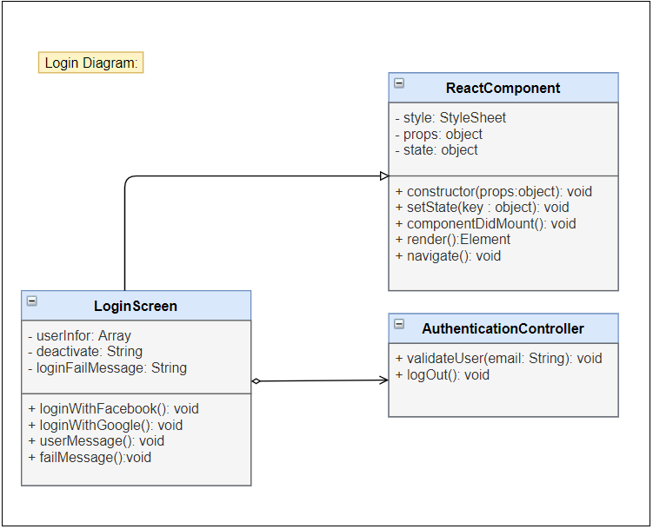

Figure - Login class diagram

## 

|  |  |  |  |  |  |
| --- | --- | --- | --- | --- | --- |
| **Name** | AuthController | | | **Type** | Class |
| **Description** | Controller class to control authentication. | | | | |
| **Attributes** | | | | | |
| **Name** | **Type** | **Visibility** | **Description** | | |
|  |  |  |  | | |
| **Operations** | | | | | |
| **Name** | **Type** | **Visibility** | **Description** | | |
| validateUser(email) | void | public | Validate the email in database. | | |
|  |  |  |  | | |
|  |  |  |  | | |

|  |  |  |  |  |  |
| --- | --- | --- | --- | --- | --- |
| **Name** | LoginScreen | | | **Type** | Class |
| **Description** | A class that displays login screen. | | | | |
| **Attributes** | | | | | |
| **Name** | **Type** | **Visibility** | **Description** | | |
| loading | boolean | private | state of loading modal | | |
|  |  |  |  | | |
|  |  |  |  | | |
| **Operations** | | | | | |
| **Name** | **Type** | **Visibility** | **Description** | | |
| loginWithGoogle() | void | public | Handle login with google | | |
| loginWithFacebook() | void | public | Handle login with facebook | | |
| saveUserInfo() | void | public | Save user information in AsyncStorage | | |
| userMessage() | void | public | Display deactivated message | | |
| createNewUser() | void | public | Navigate to CreateUser Screen | | |
|  |  |  |  | | |

**\*Login with Google sequence diagram**

Figure - Login with Google sequence diagram

**\*Login with Facebook sequence diagram**

Figure - Login with Facebook class diagram

### Logout

**\*Logout class diagram**

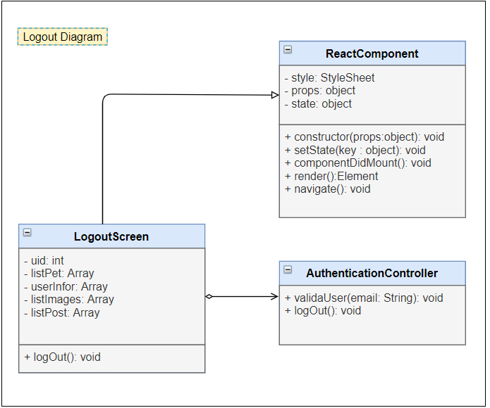

Figure - Logout class diagram

|  |  |  |  |  |  |
| --- | --- | --- | --- | --- | --- |
| **Name** | AuthController | | | **Type** | Class |
| **Description** | Controller class to control authentication. | | | | |
| **Attributes** | | | | | |
| **Name** | **Type** | **Visibility** | **Description** | | |
|  |  |  |  | | |
| **Operations** | | | | | |
| **Name** | **Type** | **Visibility** | **Description** | | |
| logOut() | void | public | Clear AnsyncStorage and logout user from application. | | |
|  |  |  |  | | |

|  |  |  |  |  |  |
| --- | --- | --- | --- | --- | --- |
| **Name** | NavScreen | | | **Type** | Class |
| **Description** | A class that displays navigator screen. | | | | |
| **Attributes** | | | | | |
| **Name** | **Type** | **Visibility** | **Description** | | |
|  |  |  |  | | |
| **Operations** | | | | | |
| **Name** | **Type** | **Visibility** | **Description** | | |
| logOut() | void | public | Handle logout from application. | | |
|  |  |  |  | | |

**\*Logout sequence diagram**

Figure - Logout sequence diagram

### Matching

**\*Matching class diagram**

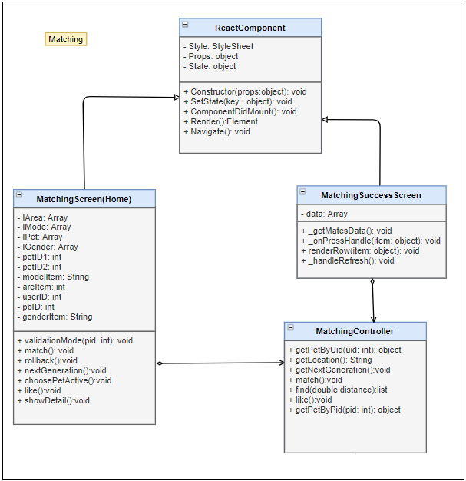

Figure - class diagram

|  |  |  |  |  |  |
| --- | --- | --- | --- | --- | --- |
| **Name** | MatchingController | | | **Type** | Class |
| **Description** | Controller class to control User and some functions relative. | | | | |
| **Attributes** | | | | | |
| **Name** | **Type** | **Visibility** | **Description** | | |
|  |  |  |  | | |
| **Operations** | | | | | |
| **Name** | **Type** | **Visibility** | **Description** | | |
| getPetByUid (id) | object | public | Get Information of list pet with UserId in database | | |
| getLocation () | void | public | Get real location of user | | |
| getNextGeneration() | void | public | Get new baby pet for 2 parent pets | | |
| match() | void | public | Match random for active pet | | |
| like() | void | public | Reaction a pet to rankking or show | | |
| getPetByPid(pid: int) | object | public | Get Information of pet with PetId in database | | |

|  |  |  |  |  |  |
| --- | --- | --- | --- | --- | --- |
| **Name** | Matching screen | | | **Type** | Class |
| **Description** |  | | | | |
| **Attributes** | | | | | |
| **Name** | **Type** | **Visibility** | **Description** | | |
|  |  |  |  | | |
| **Operations** | | | | | |
| **Name** | **Type** | **Visibility** | **Description** | | |
|  |  |  |  | | |
|  |  |  |  | | |

|  |  |  |  |  |  |
| --- | --- | --- | --- | --- | --- |
| **Name** | MatchingSuccess screen | | | **Type** | Class |
| **Description** |  | | | | |
| **Attributes** | | | | | |
| **Name** | **Type** | **Visibility** | **Description** | | |
|  |  |  |  | | |
| **Operations** | | | | | |
| **Name** | **Type** | **Visibility** | **Description** | | |
|  |  |  |  | | |
|  |  |  |  | | |

**\* sequence diagram**

Figure - sequence diagram

### Chatting

**\* class diagram**

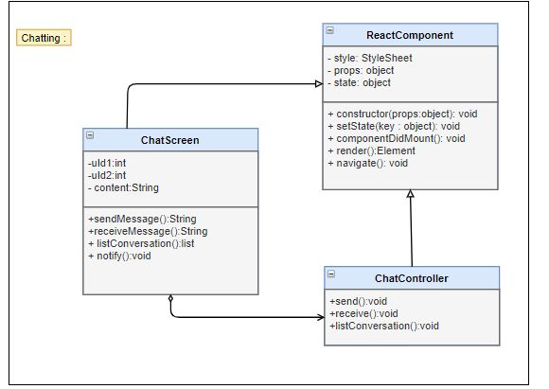

Figure - class diagram

|  |  |  |  |  |  |
| --- | --- | --- | --- | --- | --- |
| **Name** | ChatController | | | **Type** | Class |
| **Description** | Controller control chat messages and conversations | | | | |
| **Attributes** | | | | | |
| **Name** | **Type** | **Visibility** | **Description** | | |
|  |  |  |  | | |
| **Operations** | | | | | |
| **Name** | **Type** | **Visibility** | **Description** | | |
| send() | void | public | Send message ( real time) | | |
| receive() | void | public | Recive messages (real time) | | |
| listConversation | list | public | Show list all of conversation | | |

|  |  |  |  |  |  |
| --- | --- | --- | --- | --- | --- |
| **Name** |  | | | **Type** | Class |
| **Description** |  | | | | |
| **Attributes** | | | | | |
| **Name** | **Type** | **Visibility** | **Description** | | |
|  |  |  |  | | |
| **Operations** | | | | | |
| **Name** | **Type** | **Visibility** | **Description** | | |
|  |  |  |  | | |
|  |  |  |  | | |

**\* sequence diagram**

Figure - sequence diagram

### Ranking

**\* class diagram**

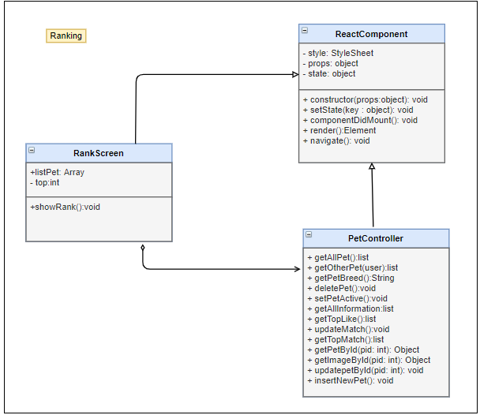

Figure - class diagram

|  |  |  |  |  |  |
| --- | --- | --- | --- | --- | --- |
| **Name** | PetController | | | **Type** | Class |
| **Description** | Controller class to control Pet and some functions relative. | | | | |
| **Attributes** | | | | | |
| **Name** | **Type** | **Visibility** | **Description** | | |
|  |  |  |  | | |
| **Operations** | | | | | |
| **Name** | **Type** | **Visibility** | **Description** | | |
| getAllPet | list | public | Get list all of pet belong to this user | | |
| deletePet | void | public | Delete a pet in list pets | | |
| setPetActive | void | public | Set a pet is active to match | | |
| getAllInformation | list | public | Get all information of pet on list pet | | |
| getTopLike | list | public | Get top pet have most liked | | |
| updateMatch | void | public | Update match record in database | | |
| getTopMatch | list | public | Get top pets are most matched | | |
| getPetById(pid: int) | Object | public | Get Pet by PetID | | |
| getImageById(pid: int) | Object | public | Get all image by petID | | |

|  |  |  |  |  |  |
| --- | --- | --- | --- | --- | --- |
| **Name** |  | | | **Type** | Class |
| **Description** |  | | | | |
| **Attributes** | | | | | |
| **Name** | **Type** | **Visibility** | **Description** | | |
|  |  |  |  | | |
| **Operations** | | | | | |
| **Name** | **Type** | **Visibility** | **Description** | | |
|  |  |  |  | | |
|  |  |  |  | | |

**\* sequence diagram**

Figure - sequence diagram

### Feedback

**\* class diagram**

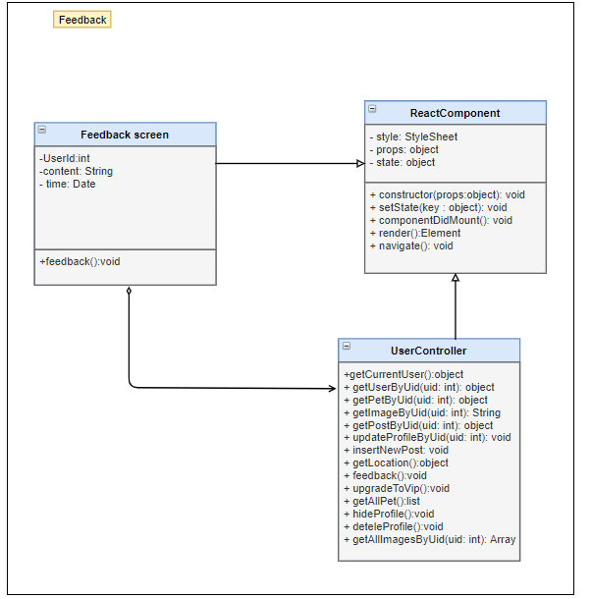

Figure - class diagram

|  |  |  |  |  |  |
| --- | --- | --- | --- | --- | --- |
| **Name** | UserController | | | **Type** | Class |
| **Description** | Controller class to control Matching and some functions relative. | | | | |
| **Attributes** | | | | | |
| **Name** | **Type** | **Visibility** | **Description** | | |
|  |  |  |  | | |
| **Operations** | | | | | |
| **Name** | **Type** | **Visibility** | **Description** | | |
| getCurrentUser() | object | public | Get all information of user, which did login | | |
| getUserByUid(uID) | object | public | Get all information of user with Uid | | |
| getImageByUid(()) | String | public | Select image form database by Uid | | |
| getLocation() | object | public | Get location( latitude and longitude) of user | | |
| Feedback() | void | public | Send feedback to admin | | |
| getAllImagesByUid() | Array | public | Get list of image User has | | |

|  |  |  |  |  |  |
| --- | --- | --- | --- | --- | --- |
| **Name** |  | | | **Type** | Class |
| **Description** |  | | | | |
| **Attributes** | | | | | |
| **Name** | **Type** | **Visibility** | **Description** | | |
|  |  |  |  | | |
| **Operations** | | | | | |
| **Name** | **Type** | **Visibility** | **Description** | | |
|  |  |  |  | | |
|  |  |  |  | | |

**\* sequence diagram**

Figure - sequence diagram

### React pet

**\* class diagram**

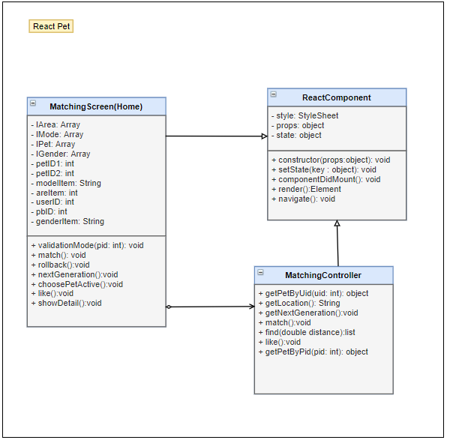

Figure - class diagram

|  |  |  |  |  |  |
| --- | --- | --- | --- | --- | --- |
| **Name** | PetController | | | **Type** | Class |
| **Description** | Controller class to control Pet and some functions relative. | | | | |
| **Attributes** | | | | | |
| **Name** | **Type** | **Visibility** | **Description** | | |
|  |  |  |  | | |
| **Operations** | | | | | |
| **Name** | **Type** | **Visibility** | **Description** | | |
| getAllPet | list | public | Get list all of pet belong to this user | | |
| getOtherPet(user) | list | public | Get list all of Pet by userID | | |
| getPetBreed | String | public | Get pet breed for pet | | |
| setPetActive | void | public | Set a pet is active to match | | |
| getAllInformation | list | public | Get all information of pet on list pet | | |
| getTopLike | list | public | Get top pet have most liked | | |
| updateMatch | void | public | Update match record in database | | |
| getTopMatch | list | public | Get top pets are most matched | | |
| getPetById(pid: int) | Object | public | Get Pet by PetID | | |
| getImageById(pid: int) | Object | public | Get all image by petID | | |

|  |  |  |  |  |  |
| --- | --- | --- | --- | --- | --- |
| **Name** |  | | | **Type** | Class |
| **Description** |  | | | | |
| **Attributes** | | | | | |
| **Name** | **Type** | **Visibility** | **Description** | | |
|  |  |  |  | | |
| **Operations** | | | | | |
| **Name** | **Type** | **Visibility** | **Description** | | |
|  |  |  |  | | |
|  |  |  |  | | |

**\* sequence diagram**

Figure - sequence diagram

### View other user

**\* class diagram**

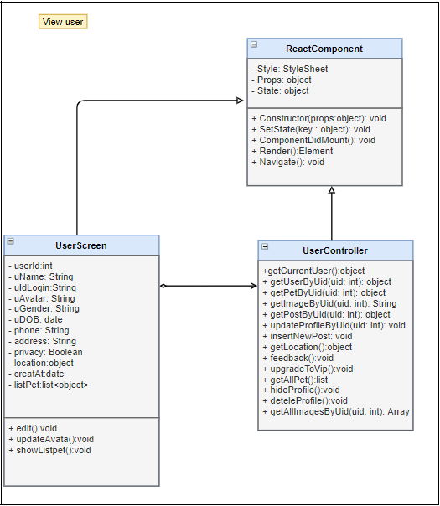

Figure - class diagram

|  |  |  |  |  |  |
| --- | --- | --- | --- | --- | --- |
| **Name** | UserController | | | **Type** | Class |
| **Description** | Controller class to control Matching and some functions relative. | | | | |
| **Attributes** | | | | | |
| **Name** | **Type** | **Visibility** | **Description** | | |
|  |  |  |  | | |
| **Operations** | | | | | |
| **Name** | **Type** | **Visibility** | **Description** | | |
| getCurrentUser() | object | public | Get all information of user, which did login | | |
| getUserByUid(uID) | object | public | Get all information of user with Uid | | |
| getPetByPid(pID) | object | public | Get information of Pet with  PetID | | |
| getImageByUid(()) | String | public | Select image form database by Uid | | |
| updateProfileByUid() | void | public | Update detail of user profile | | |
| getLocation() | object | public | Get location( latitude and longitude) of user | | |
| getAllPet() | list | public | Get all information of list pet Pet  For this user | | |
| getAllImagesByUid() | Array | public | Get list of image User has | | |

|  |  |  |  |  |  |
| --- | --- | --- | --- | --- | --- |
| **Name** |  | | | **Type** | Class |
| **Description** |  | | | | |
| **Attributes** | | | | | |
| **Name** | **Type** | **Visibility** | **Description** | | |
|  |  |  |  | | |
| **Operations** | | | | | |
| **Name** | **Type** | **Visibility** | **Description** | | |
|  |  |  |  | | |
|  |  |  |  | | |

**\* sequence diagram**

Figure - sequence diagram

### View other user’s pets

**\* class diagram**

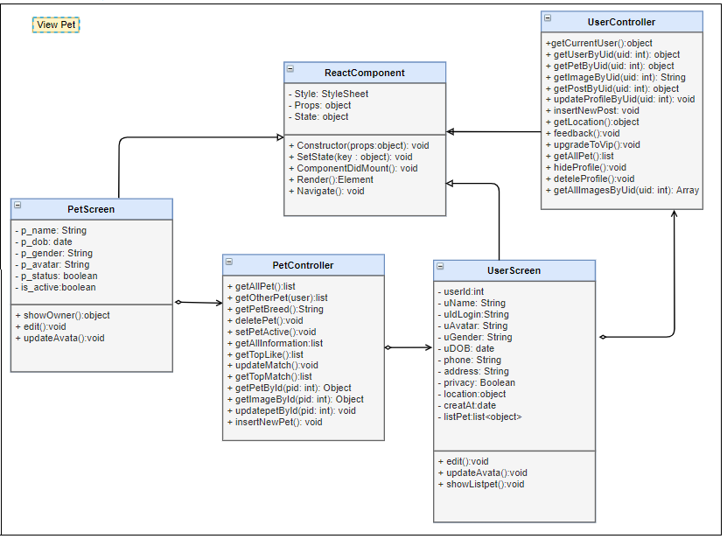

Figure - class diagram

|  |  |  |  |  |  |
| --- | --- | --- | --- | --- | --- |
| **Name** | UserController | | | **Type** | Class |
| **Description** | Controller class to control Matching and some functions relative. | | | | |
| **Attributes** | | | | | |
| **Name** | **Type** | **Visibility** | **Description** | | |
|  |  |  |  | | |
| **Operations** | | | | | |
| **Name** | **Type** | **Visibility** | **Description** | | |
| getCurrentUser() | object | public | Get all information of user, which did login | | |
| getUserByUid(uID) | object | public | Get all information of user with Uid | | |
| getPetByPid(pID) | object | public | Get information of Pet with  PetID | | |
| getImageByUid(()) | String | public | Select image form database by Uid | | |
| updateProfileByUid() | void | public | Update detail of user profile | | |
| getLocation() | object | public | Get location( latitude and longitude) of user | | |
| getAllImagesByUid() | Array | public | Get list of image User has | | |

|  |  |  |  |  |  |
| --- | --- | --- | --- | --- | --- |
| **Name** | PetController | | | **Type** | Class |
| **Description** | Controller class to control Pet and some functions relative. | | | | |
| **Attributes** | | | | | |
| **Name** | **Type** | **Visibility** | **Description** | | |
|  |  |  |  | | |
| **Operations** | | | | | |
| **Name** | **Type** | **Visibility** | **Description** | | |
| getAllPet | list | public | Get list all of pet belong to this user | | |
| getOtherPet(user) | list | public | Get list all of Pet by userID | | |
| getPetBreed | String | public | Get pet breed for pet | | |
| getAllInformation | list | public | Get all information of pet on list pet | | |
| getTopLike | list | public | Get top pet have most liked | | |
| getTopMatch | list | public | Get top pets are most matched | | |
| getPetById(pid: int) | Object | public | Get Pet by PetID | | |
| getImageById(pid: int) | Object | public | Get all image by petID | | |
| insertNewPet() | void | public | Create a new pet | | |

|  |  |  |  |  |  |
| --- | --- | --- | --- | --- | --- |
| **Name** |  | | | **Type** | Class |
| **Description** |  | | | | |
| **Attributes** | | | | | |
| **Name** | **Type** | **Visibility** | **Description** | | |
|  |  |  |  | | |
| **Operations** | | | | | |
| **Name** | **Type** | **Visibility** | **Description** | | |
|  |  |  |  | | |
|  |  |  |  | | |

|  |  |  |  |  |  |
| --- | --- | --- | --- | --- | --- |
| **Name** |  | | | **Type** | Class |
| **Description** |  | | | | |
| **Attributes** | | | | | |
| **Name** | **Type** | **Visibility** | **Description** | | |
|  |  |  |  | | |
| **Operations** | | | | | |
| **Name** | **Type** | **Visibility** | **Description** | | |
|  |  |  |  | | |
|  |  |  |  | | |

**\* sequence diagram**

Figure - sequence diagram

### Hide profile

**\* class diagram**

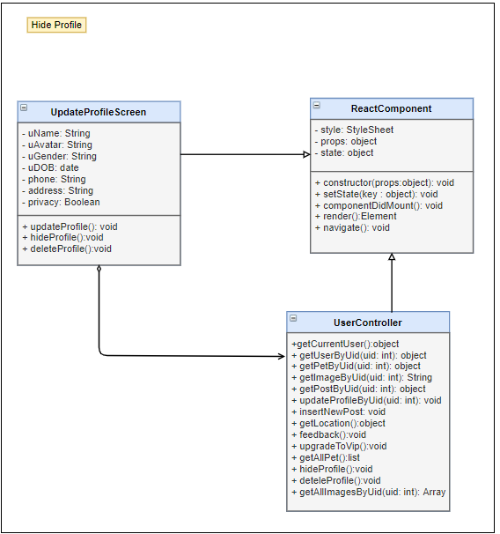

Figure - class diagram

|  |  |  |  |  |  |
| --- | --- | --- | --- | --- | --- |
| **Name** | UserController | | | **Type** | Class |
| **Description** | Controller class to control Matching and some functions relative. | | | | |
| **Attributes** | | | | | |
| **Name** | **Type** | **Visibility** | **Description** | | |
|  |  |  |  | | |
| **Operations** | | | | | |
| **Name** | **Type** | **Visibility** | **Description** | | |
| getCurrentUser() | object | public | Get all information of user, which did login | | |
| getUserByUid(uID) | object | public | Get all information of user with Uid | | |
| getImageByUid(()) | String | public | Select image form database by Uid | | |
| updateProfileByUid() | void | public | Update detail of user profile | | |
| getLocation() | object | public | Get location( latitude and longitude) of user | | |
| hideProfile() | void | public | Hide of unhide user profile | | |
| getAllImagesByUid() | Array | public | Get list of image User has | | |

|  |  |  |  |  |  |
| --- | --- | --- | --- | --- | --- |
| **Name** |  | | | **Type** | Class |
| **Description** |  | | | | |
| **Attributes** | | | | | |
| **Name** | **Type** | **Visibility** | **Description** | | |
|  |  |  |  | | |
| **Operations** | | | | | |
| **Name** | **Type** | **Visibility** | **Description** | | |
|  |  |  |  | | |
|  |  |  |  | | |

**\* sequence diagram**

Figure - sequence diagram

### Edit user’s profile

**\* class diagram**

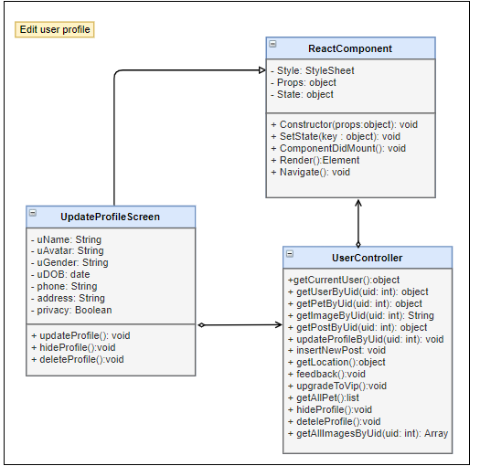

Figure - class diagram

|  |  |  |  |  |  |
| --- | --- | --- | --- | --- | --- |
| **Name** | UserController | | | **Type** | Class |
| **Description** | Controller class to control Matching and some functions relative. | | | | |
| **Attributes** | | | | | |
| **Name** | **Type** | **Visibility** | **Description** | | |
|  |  |  |  | | |
| **Operations** | | | | | |
| **Name** | **Type** | **Visibility** | **Description** | | |
| getCurrentUser() | object | public | Get all information of user, which did login | | |
| getPetByPid(pID) | object | public | Get information of Pet with  PetID | | |
| getImageByUid(()) | String | public | Select image form database by Uid | | |
| updateProfileByUid() | void | public | Update detail of user profile | | |
| getLocation() | object | public | Get location( latitude and longitude) of user | | |
| upgradeToVip() | void | public | Update user role to Vip user | | |
| getAllPet() | list | public | Get all information of list pet Pet  For this user | | |
| deteleProfile() | void | public | Delete physical all of information for this user profile | | |
| getAllImagesByUid() | Array | public | Get list of image User has | | |

|  |  |  |  |  |  |
| --- | --- | --- | --- | --- | --- |
| **Name** |  | | | **Type** | Class |
| **Description** |  | | | | |
| **Attributes** | | | | | |
| **Name** | **Type** | **Visibility** | **Description** | | |
|  |  |  |  | | |
| **Operations** | | | | | |
| **Name** | **Type** | **Visibility** | **Description** | | |
|  |  |  |  | | |
|  |  |  |  | | |

**\* sequence diagram**

Figure - sequence diagram

### Delete user’s profile

**\* class diagram**

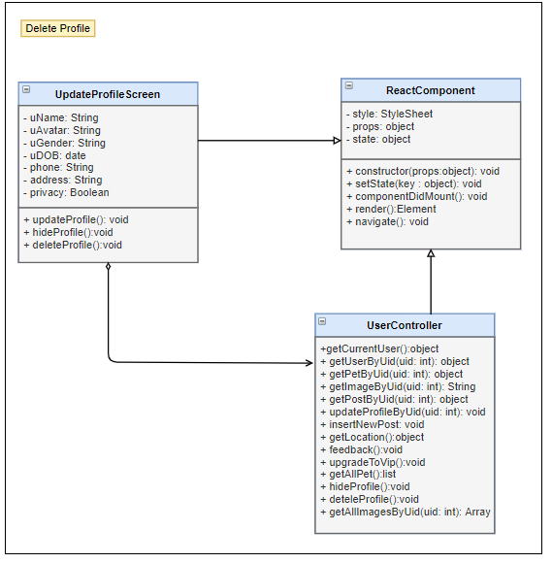

Figure - class diagram

|  |  |  |  |  |  |
| --- | --- | --- | --- | --- | --- |
| **Name** | UserController | | | **Type** | Class |
| **Description** | Controller class to control Matching and some functions relative. | | | | |
| **Attributes** | | | | | |
| **Name** | **Type** | **Visibility** | **Description** | | |
|  |  |  |  | | |
| **Operations** | | | | | |
| **Name** | **Type** | **Visibility** | **Description** | | |
| getCurrentUser() | object | public | Get all information of user, which did login | | |
| getImageByUid(()) | String | public | Select image form database by Uid | | |
| updateProfileByUid() | void | public | Update detail of user profile | | |
| getLocation() | object | public | Get location( latitude and longitude) of user | | |
| deteleProfile() | void | public | Delete physical all of information for this user profile | | |
| getAllImagesByUid() | Array | public | Get list of image User has | | |

|  |  |  |  |  |  |
| --- | --- | --- | --- | --- | --- |
| **Name** |  | | | **Type** | Class |
| **Description** |  | | | | |
| **Attributes** | | | | | |
| **Name** | **Type** | **Visibility** | **Description** | | |
|  |  |  |  | | |
| **Operations** | | | | | |
| **Name** | **Type** | **Visibility** | **Description** | | |
|  |  |  |  | | |
|  |  |  |  | | |

**\* sequence diagram**

Figure - sequence diagram

### Create new pet

**\* class diagram**

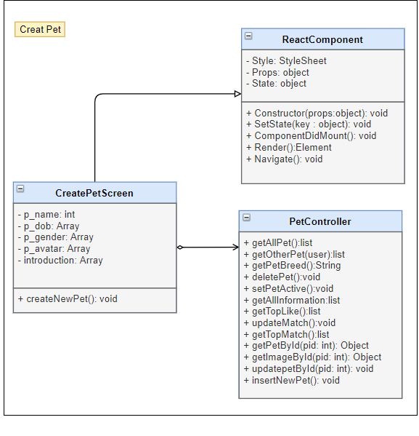

Figure - class diagram

|  |  |  |  |  |  |
| --- | --- | --- | --- | --- | --- |
| **Name** | PetController | | | **Type** | Class |
| **Description** | Controller class to control Pet and some functions relative. | | | | |
| **Attributes** | | | | | |
| **Name** | **Type** | **Visibility** | **Description** | | |
|  |  |  |  | | |
| **Operations** | | | | | |
| **Name** | **Type** | **Visibility** | **Description** | | |
| getAllPet | list | public | Get list all of pet belong to this user | | |
| getPetBreed | String | public | Get pet breed for pet | | |
| setPetActive | void | public | Set a pet is active to match | | |
| getAllInformation | list | public | Get all information of pet on list pet | | |
| getPetById(pid: int) | Object | public | Get Pet by PetID | | |
| getImageById(pid: int) | Object | public | Get all image by petID | | |
| insertNewPet() | void | public | Create a new pet | | |

|  |  |  |  |  |  |
| --- | --- | --- | --- | --- | --- |
| **Name** |  | | | **Type** | Class |
| **Description** |  | | | | |
| **Attributes** | | | | | |
| **Name** | **Type** | **Visibility** | **Description** | | |
|  |  |  |  | | |
| **Operations** | | | | | |
| **Name** | **Type** | **Visibility** | **Description** | | |
|  |  |  |  | | |
|  |  |  |  | | |

**\* sequence diagram**

Figure - sequence diagram

### Edit pet’s profile

**\* class diagram**

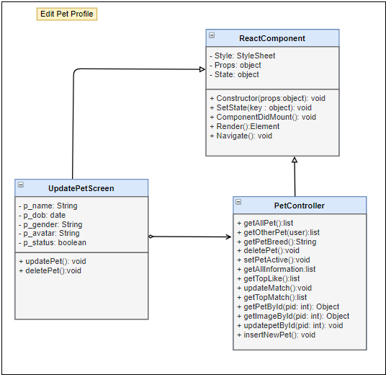

Figure - class diagram

|  |  |  |  |  |  |
| --- | --- | --- | --- | --- | --- |
| **Name** | PetController | | | **Type** | Class |
| **Description** | Controller class to control Pet and some functions relative. | | | | |
| **Attributes** | | | | | |
| **Name** | **Type** | **Visibility** | **Description** | | |
|  |  |  |  | | |
| **Operations** | | | | | |
| **Name** | **Type** | **Visibility** | **Description** | | |
| getAllPet | list | public | Get list all of pet belong to this user | | |
| getOtherPet(user) | list | public | Get list all of Pet by userID | | |
| getPetBreed | String | public | Get pet breed for pet | | |
| setPetActive | void | public | Set a pet is active to match | | |
| getAllInformation | list | public | Get all information of pet on list pet | | |
| getPetById(pid: int) | Object | public | Get Pet by PetID | | |
| getImageById(pid: int) | Object | public | Get all image by petID | | |
| updatepetById(pid: int) | void | public | Update Pet by petID | | |

|  |  |  |  |  |  |
| --- | --- | --- | --- | --- | --- |
| **Name** |  | | | **Type** | Class |
| **Description** |  | | | | |
| **Attributes** | | | | | |
| **Name** | **Type** | **Visibility** | **Description** | | |
|  |  |  |  | | |
| **Operations** | | | | | |
| **Name** | **Type** | **Visibility** | **Description** | | |
|  |  |  |  | | |
|  |  |  |  | | |

**\* sequence diagram**

Figure - sequence diagram

### Delete pet’s profile

**\* class diagram**

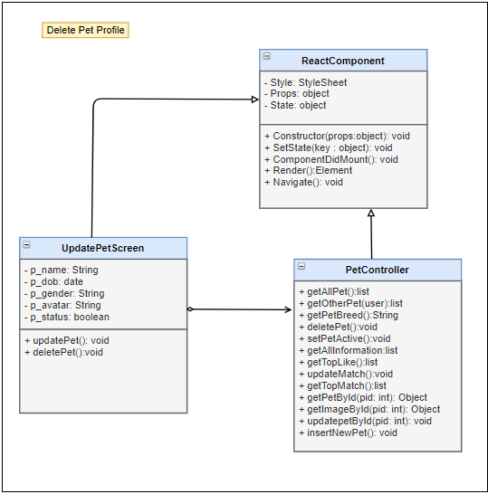

Figure - class diagram

|  |  |  |  |  |  |
| --- | --- | --- | --- | --- | --- |
| **Name** | PetController | | | **Type** | Class |
| **Description** | Controller class to control Pet and some functions relative. | | | | |
| **Attributes** | | | | | |
| **Name** | **Type** | **Visibility** | **Description** | | |
|  |  |  |  | | |
| **Operations** | | | | | |
| **Name** | **Type** | **Visibility** | **Description** | | |
| getAllPet | list | public | Get list all of pet belong to this user | | |
| getOtherPet(user) | list | public | Get list all of Pet by userID | | |
| getPetBreed | String | public | Get pet breed for pet | | |
| deletePet | void | public | Delete a pet in list pets | | |
| setPetActive | void | public | Set a pet is active to match | | |
| getAllInformation | list | public | Get all information of pet on list pet | | |
| getPetById(pid: int) | Object | public | Get Pet by PetID | | |
| getImageById(pid: int) | Object | public | Get all image by petID | | |

|  |  |  |  |  |  |
| --- | --- | --- | --- | --- | --- |
| **Name** |  | | | **Type** | Class |
| **Description** |  | | | | |
| **Attributes** | | | | | |
| **Name** | **Type** | **Visibility** | **Description** | | |
|  |  |  |  | | |
| **Operations** | | | | | |
| **Name** | **Type** | **Visibility** | **Description** | | |
|  |  |  |  | | |
|  |  |  |  | | |

**\* sequence diagram**

Figure - sequence diagram

### Find

**\* class diagram**

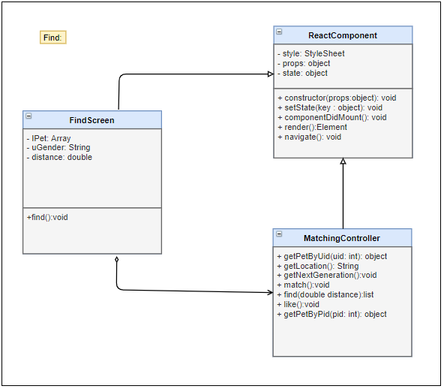

Figure - class diagram

|  |  |  |  |  |  |
| --- | --- | --- | --- | --- | --- |
| **Name** | MatchingController | | | **Type** | Class |
| **Description** | Controller class to control User and some functions relative. | | | | |
| **Attributes** | | | | | |
| **Name** | **Type** | **Visibility** | **Description** | | |
|  |  |  |  | | |
| **Operations** | | | | | |
| **Name** | **Type** | **Visibility** | **Description** | | |
| getPetByUid (id) | object | public | Get Information of list pet with UserId in database | | |
| getLocation () | void | public | Get real location of user | | |
| find(double distance) | list | public | find user around with distance | | |
| like() | void | public | Reaction a pet to rankking or show | | |
| getPetByPid(pid: int) | object | public | Get Information of pet with PetId in database | | |

|  |  |  |  |  |  |
| --- | --- | --- | --- | --- | --- |
| **Name** |  | | | **Type** | Class |
| **Description** |  | | | | |
| **Attributes** | | | | | |
| **Name** | **Type** | **Visibility** | **Description** | | |
|  |  |  |  | | |
| **Operations** | | | | | |
| **Name** | **Type** | **Visibility** | **Description** | | |
|  |  |  |  | | |
|  |  |  |  | | |

**\* sequence diagram**

Figure - sequence diagram

### Get next generation pet

**\* class diagram**

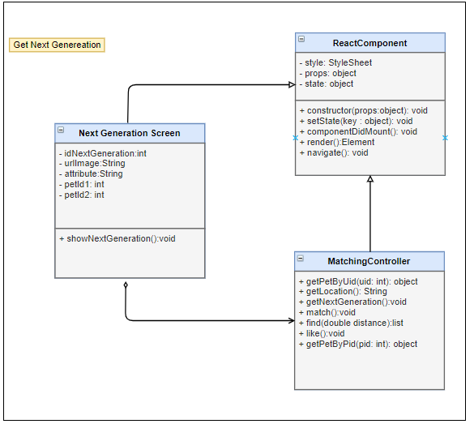

Figure - class diagram

|  |  |  |  |  |  |
| --- | --- | --- | --- | --- | --- |
| **Name** | MatchingController | | | **Type** | Class |
| **Description** | Controller class to control User and some functions relative. | | | | |
| **Attributes** | | | | | |
| **Name** | **Type** | **Visibility** | **Description** | | |
|  |  |  |  | | |
| **Operations** | | | | | |
| **Name** | **Type** | **Visibility** | **Description** | | |
| getPetByUid (id) | object | public | Get Information of list pet with UserId in database | | |
| getLocation () | void | public | Get real location of user | | |
| getNextGeneration() | void | public | Get new baby pet for 2 parent pets | | |
| find(double distance) | list | public | find user around with distance | | |
| getPetByPid(pid: int) | object | public | Get Information of pet with PetId in database | | |

|  |  |  |  |  |  |
| --- | --- | --- | --- | --- | --- |
| **Name** |  | | | **Type** | Class |
| **Description** |  | | | | |
| **Attributes** | | | | | |
| **Name** | **Type** | **Visibility** | **Description** | | |
|  |  |  |  | | |
| **Operations** | | | | | |
| **Name** | **Type** | **Visibility** | **Description** | | |
|  |  |  |  | | |
|  |  |  |  | | |

**\* sequence diagram**

Figure - sequence diagram

### Login/Logout with account

**\* class diagram**

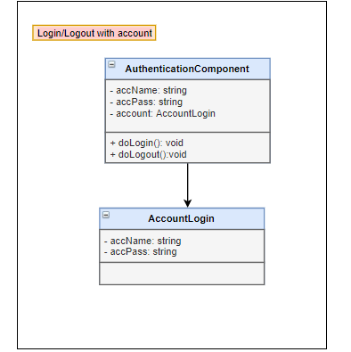

Figure - class diagram

|  |  |  |  |  |  |
| --- | --- | --- | --- | --- | --- |
| **Name** |  | | | **Type** | Class |
| **Description** |  | | | | |
| **Attributes** | | | | | |
| **Name** | **Type** | **Visibility** | **Description** | | |
|  |  |  |  | | |
| **Operations** | | | | | |
| **Name** | **Type** | **Visibility** | **Description** | | |
|  |  |  |  | | |
|  |  |  |  | | |

|  |  |  |  |  |  |
| --- | --- | --- | --- | --- | --- |
| **Name** |  | | | **Type** | Class |
| **Description** |  | | | | |
| **Attributes** | | | | | |
| **Name** | **Type** | **Visibility** | **Description** | | |
|  |  |  |  | | |
| **Operations** | | | | | |
| **Name** | **Type** | **Visibility** | **Description** | | |
|  |  |  |  | | |
|  |  |  |  | | |

**\* sequence diagram**

Figure - sequence diagram

### Enable/Disable Account

**\* class diagram**

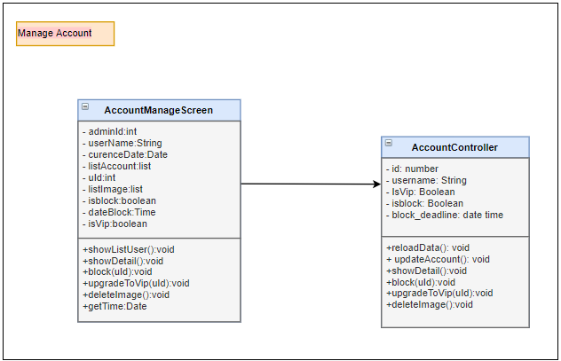

Figure - class diagram

|  |  |  |  |  |  |
| --- | --- | --- | --- | --- | --- |
| **Name** |  | | | **Type** | Class |
| **Description** |  | | | | |
| **Attributes** | | | | | |
| **Name** | **Type** | **Visibility** | **Description** | | |
|  |  |  |  | | |
| **Operations** | | | | | |
| **Name** | **Type** | **Visibility** | **Description** | | |
|  |  |  |  | | |
|  |  |  |  | | |

|  |  |  |  |  |  |
| --- | --- | --- | --- | --- | --- |
| **Name** |  | | | **Type** | Class |
| **Description** |  | | | | |
| **Attributes** | | | | | |
| **Name** | **Type** | **Visibility** | **Description** | | |
|  |  |  |  | | |
| **Operations** | | | | | |
| **Name** | **Type** | **Visibility** | **Description** | | |
|  |  |  |  | | |
|  |  |  |  | | |

**\* sequence diagram**

Figure - sequence diagram

### Delete Images

**\* class diagram**



Figure - class diagram

|  |  |  |  |  |  |
| --- | --- | --- | --- | --- | --- |
| **Name** |  | | | **Type** | Class |
| **Description** |  | | | | |
| **Attributes** | | | | | |
| **Name** | **Type** | **Visibility** | **Description** | | |
|  |  |  |  | | |
| **Operations** | | | | | |
| **Name** | **Type** | **Visibility** | **Description** | | |
|  |  |  |  | | |
|  |  |  |  | | |

|  |  |  |  |  |  |
| --- | --- | --- | --- | --- | --- |
| **Name** |  | | | **Type** | Class |
| **Description** |  | | | | |
| **Attributes** | | | | | |
| **Name** | **Type** | **Visibility** | **Description** | | |
|  |  |  |  | | |
| **Operations** | | | | | |
| **Name** | **Type** | **Visibility** | **Description** | | |
|  |  |  |  | | |
|  |  |  |  | | |

**\* sequence diagram**

Figure - sequence diagram

### Manage system

**\* class diagram**

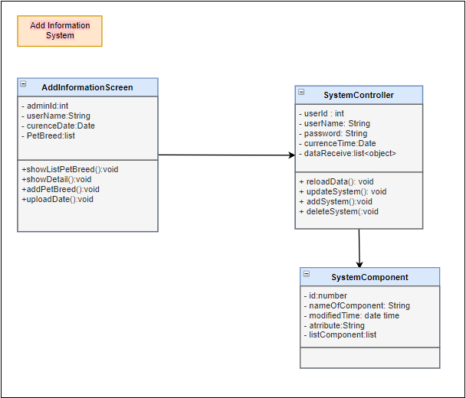

Figure - class diagram

|  |  |  |  |  |  |
| --- | --- | --- | --- | --- | --- |
| **Name** |  | | | **Type** | Class |
| **Description** |  | | | | |
| **Attributes** | | | | | |
| **Name** | **Type** | **Visibility** | **Description** | | |
|  |  |  |  | | |
| **Operations** | | | | | |
| **Name** | **Type** | **Visibility** | **Description** | | |
|  |  |  |  | | |
|  |  |  |  | | |

|  |  |  |  |  |  |
| --- | --- | --- | --- | --- | --- |
| **Name** |  | | | **Type** | Class |
| **Description** |  | | | | |
| **Attributes** | | | | | |
| **Name** | **Type** | **Visibility** | **Description** | | |
|  |  |  |  | | |
| **Operations** | | | | | |
| **Name** | **Type** | **Visibility** | **Description** | | |
|  |  |  |  | | |
|  |  |  |  | | |

**\* sequence diagram**

Figure - sequence diagram

**\* class diagram**

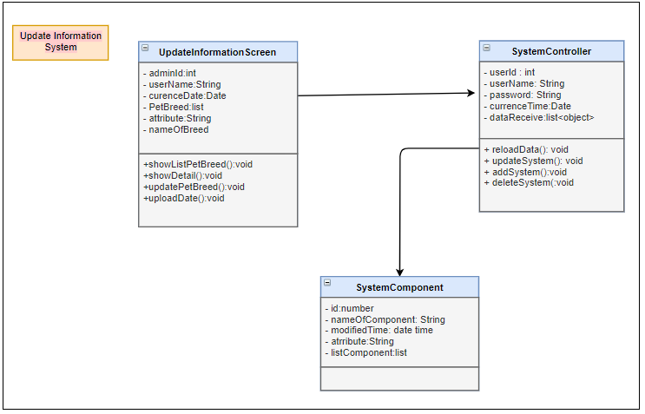

Figure - class diagram

|  |  |  |  |  |  |
| --- | --- | --- | --- | --- | --- |
| **Name** |  | | | **Type** | Class |
| **Description** |  | | | | |
| **Attributes** | | | | | |
| **Name** | **Type** | **Visibility** | **Description** | | |
|  |  |  |  | | |
| **Operations** | | | | | |
| **Name** | **Type** | **Visibility** | **Description** | | |
|  |  |  |  | | |
|  |  |  |  | | |

|  |  |  |  |  |  |
| --- | --- | --- | --- | --- | --- |
| **Name** |  | | | **Type** | Class |
| **Description** |  | | | | |
| **Attributes** | | | | | |
| **Name** | **Type** | **Visibility** | **Description** | | |
|  |  |  |  | | |
| **Operations** | | | | | |
| **Name** | **Type** | **Visibility** | **Description** | | |
|  |  |  |  | | |
|  |  |  |  | | |

**\* sequence diagram**

Figure - sequence diagram

**\* class diagram**

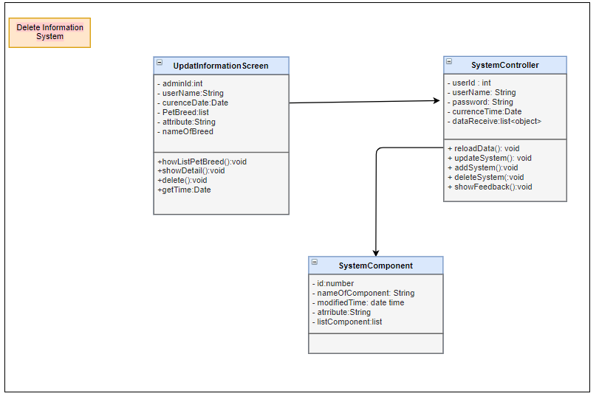

Figure - class diagram

|  |  |  |  |  |  |
| --- | --- | --- | --- | --- | --- |
| **Name** |  | | | **Type** | Class |
| **Description** |  | | | | |
| **Attributes** | | | | | |
| **Name** | **Type** | **Visibility** | **Description** | | |
|  |  |  |  | | |
| **Operations** | | | | | |
| **Name** | **Type** | **Visibility** | **Description** | | |
|  |  |  |  | | |
|  |  |  |  | | |

|  |  |  |  |  |  |
| --- | --- | --- | --- | --- | --- |
| **Name** |  | | | **Type** | Class |
| **Description** |  | | | | |
| **Attributes** | | | | | |
| **Name** | **Type** | **Visibility** | **Description** | | |
|  |  |  |  | | |
| **Operations** | | | | | |
| **Name** | **Type** | **Visibility** | **Description** | | |
|  |  |  |  | | |
|  |  |  |  | | |

**\* sequence diagram**

Figure - sequence diagram

### Receive Feedback

**\* class diagram**

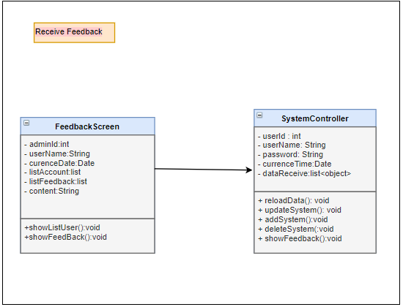

Figure - class diagram

|  |  |  |  |  |  |
| --- | --- | --- | --- | --- | --- |
| **Name** |  | | | **Type** | Class |
| **Description** |  | | | | |
| **Attributes** | | | | | |
| **Name** | **Type** | **Visibility** | **Description** | | |
|  |  |  |  | | |
| **Operations** | | | | | |
| **Name** | **Type** | **Visibility** | **Description** | | |
|  |  |  |  | | |
|  |  |  |  | | |

|  |  |  |  |  |  |
| --- | --- | --- | --- | --- | --- |
| **Name** |  | | | **Type** | Class |
| **Description** |  | | | | |
| **Attributes** | | | | | |
| **Name** | **Type** | **Visibility** | **Description** | | |
|  |  |  |  | | |
| **Operations** | | | | | |
| **Name** | **Type** | **Visibility** | **Description** | | |
|  |  |  |  | | |
|  |  |  |  | | |

**\* sequence diagram**

Figure - sequence diagram